Sanjay Sarkar

147691821

easy ticket booking

(online movie show booking)

Project Report

**MCA Project Synopsis: MCSP-060**

**Easy Ticket Booking**

(Online Movie Show Booking)

Submitted by

Mr. RAKESH SINGH (166536470) Under Guidance of Mr. Brajesh Gautam

SUBMITTED TO THE SCHOOL OF COMPUTER AND INFORMATION SCIENCES,

IGNOU

In partial fulfilment of the requirements for the award of the degree.

Table of Contents

Synopsis 1

1. Title of the Project 1

2. Project Category 1

3. Introduction 1

4. Project Abstract 1

5. Objective 1

6. Analysis 1

6.1 Economic Feasibility 1

6.2 Technical Feasibility 1

6.3 Operational Feasibility 1

7. Hardware Requirements 1

8. Software Requirements 1

9. Technologies and Languages 1

10. Data Flow Diagrams (DFDs) 1

7.1) 0 Level DFD (Context Level) 1

7.2) 1st Level DFD 1

7.3) 2nd Level DFD 1

11. *Entity Relationship Diagram* 1

12. *Hierarchy Chart* 1

13. *Use Case Diagram* 1

14. *List of modules* 1

14.1) Show representation module 1

14.2) User Management Module 1

14.3) Show Booking Module 1

14.4) Payment Gateway Module 1

14.5) Show Management Module 1

15. Bibliography 1

Report 1

Introduction 1

Abstract of the Project 1

Functionalities provided 1

Scope of the Project 1

Analysis 1

Feasibility Analysis 1

Technical Feasibility: 1

Economic Feasibility: 1

Data Flow Diagrams 1

0 level DFD (Context) 1

1st level DFD 1

2nd level DFD 1

System Modules 1

Tools and technologies needed to develop the system 1

Hardware: 1

Software: 1

Technologies/Languages 1

Tools needed to make it online 1

Database Design 1

Database Table Structures 1

Flow chart 1

System Flow Chart 1

Activity Diagram 1

Sequence Diagram (customer) 1

Collaboration Diagram (Admin) 1

Use Case Diagram 1

Admin 1

Customer & visitor 1

TESTING 1

Characteristics of testing: 1

1. Black-box testing 1

2. White-box testing 1

3. Unit testing 1

Screenshots 1

Source Codes 1

Bibliography 1

**Preface**

Most sincere thanks to Mr. Brajesh Gautam (Guide). I express my deep sense of gratitude to them for their precious and valuable guidance during the completion of this project. It is mainly due to their constant and untiring efforts, which has made it possible for this work to see the light of the day.

During this project formulation and implementation, I learned most interesting things that encourages me to build real-time projects. This happened because of encouragement from my seniors and teachers of my study center. I learned a lot from their experiences.

Finally, I am grateful to all those persons who have rendered their valuable co-operation by way of encouragement, personal interviews, sympathy and well wishes.

RAKESH SINGH

(MCA 166536470)

# Synopsis

# Title of the Project

**EASY TICKET BOOKING**

(**Online Movie Show Booking**)

# Project Category

**Website**

# Introduction

This project purpose to provide online facility to customers. Using this

system user can book the ticket, cancel the ticket and can select the

available desired seat online from anywhere anytime. This project will be

built on latest java technologies (Spring Boot, Hibernate). This is useful

for both promoters and customers equally. As the system is developed on

java technology, it will be secure, robust and scalable. And as this is a

web-based application therefore user can buy ticket from anywhere

around the world. Customers with cinema website can inquiry about new

movies, show timings and cinema locations. Customer can buy ticket

without wasting their time. Cinema owner can inform to customers about

new release and discounts and can get feedback from customer. This

feedback will be helpful for him to make new strategy for business.

Although the payment gateway will not be implemented, only demo

things what happens to real transactions will be implemented to indicate

the real scenario to pay online.

# Project Abstract

Online movie ticket booking system is basically made for providing the customers an anytime and anywhere service for booking cinema tickets and information about the movies and their schedule online.

Admin can use it to insert and delete data such as movie description, movie schedule which will update the related webpage and will be accessible by the customers.

This proposed system provides another way for the customers to buy cinema ticket. This system reduces work load on customers, it is an automatic ticket booking system.

This system is basically aimed to provide complete information of the movie and schedule to the customer, according to which he can book the tickets.

# Objective

Some important goas of movie ticket booking system are as follows:

1. Online cinema Ticket Booking System project is aimed to provide facility to book cinema tickets anytime from anywhere. It is an automatic system.
2. One objective of this project is to minimize the number of staff at the ticket-box window.
3. Promote new movies over the internet and gain maximum profit.
4. Provide a 24 x 7 service to the customer.
5. To obtain statistic information from the booking record.

# Analysis

**Feasibility Study**

## Economic Feasibility

In making recommendations a study of the economics of the proposed system should be made. The proposed system must be justifiable in terms of cost and benefit, to ensure that the investment in a new/changed system provide a reasonable return.

Cost-benefit analysis of information is complicated by the fact that many of the systems cost elements are poorly defined and that benefit can often be highly qualitative and subjective in nature.

In our proposed system various costs are evaluated. Even though finding out the costs of the proposed project is difficult we and assume and estimate the costs and benefits as follows.

According to the computerized system we propose, the costs can be broken down to two categories.

Costs associated with the development of the system.

Costs associated with operating the system.

## Technical Feasibility

During technical analysis, the technical merits of the system are studied and at the same time collecting additional information about performance, reliability, maintainability and predictability.

Technical analysis begins with an assessment of the technical viability of the proposed system.

* What technologies are required to accomplished system function and performance?
* What new materials, methods, algorithms or processes are required and what is their development risk?
* How will these obtained from technical analysis form the basis for another go/no-go decision on the test system? If the technical risk is severe, if models indicate that the desired function cannot be achieved, if the pieces just won’t fit together smoothly-it’s back to the drawing board.

As the software is very much economically feasible, then it is really important for it to be technically sound.

## Operational Feasibility

No doubt the proposed system is fully GUI based that is very user friendly and all inputs to be taken are self-explanatory even to a layman. All the interfaces are eye catching and simple full of clip arts images and descriptions.

# Hardware Requirements

The minimum possible hardware that are require developing the project and to run the project are specified below.

Processor : Pentium IV 2GHz and Above

RAM : 2 GB or more

Hard Disc : 100 GB or more

Monitor : 15” Color Monitor or advance

Keyboard : Any keyboard

Mouse : Any Mouse

Printer : In Case of printing reports

# Software Requirements

Operating System. : **Windows 7, or any version above 7**

IDE : **Eclipse/Intellij**

Server : **Apache Tomcat**

Database : **MySQL**

Browser : **Any of Chrome, Mozilla, Opera etc**.

# Technologies and Languages

Front end : **Thymleaf,** **HTML, CSS, JavaScript**

Back end : **Core Java, Spring Core, Spring MVC, Spring Data JPA, Hibernate, Spring Security**

# Data Flow Diagrams (DFDs)

## 7.1) 0 Level DFD (Context Level)

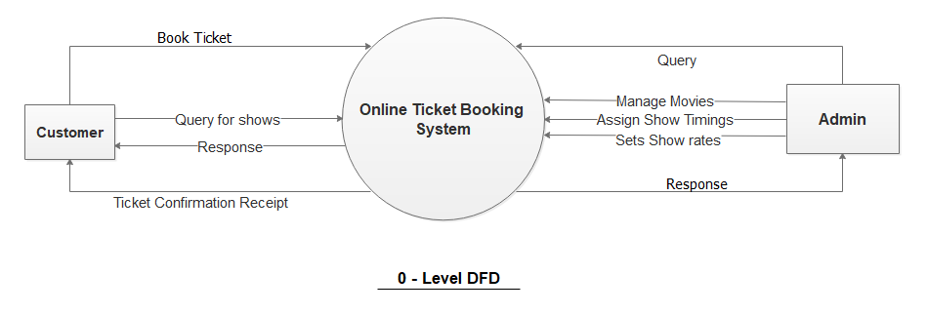

## 7.2) 1st Level DFD

## 7.3) 2nd Level DFD

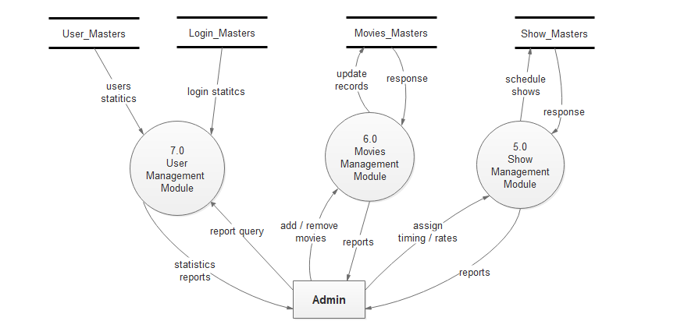

Other Process modelling diagrams will be listed and explained into the **project report.**

# Entity Relationship Diagram

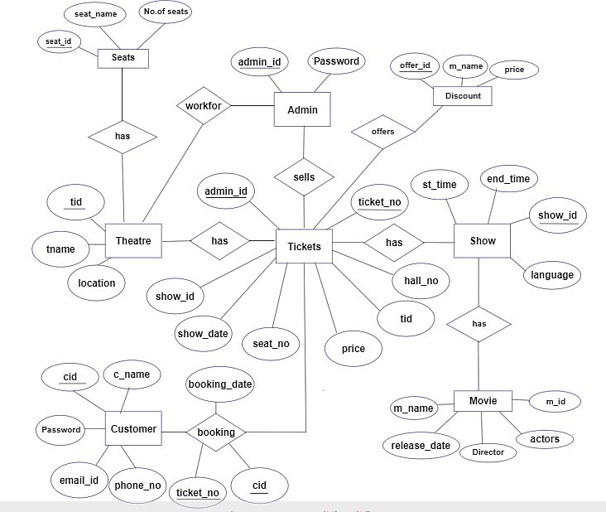

There may be slight change or other external entity may be involved as I am making this project and is not completed yet

# Hierarchy Chart

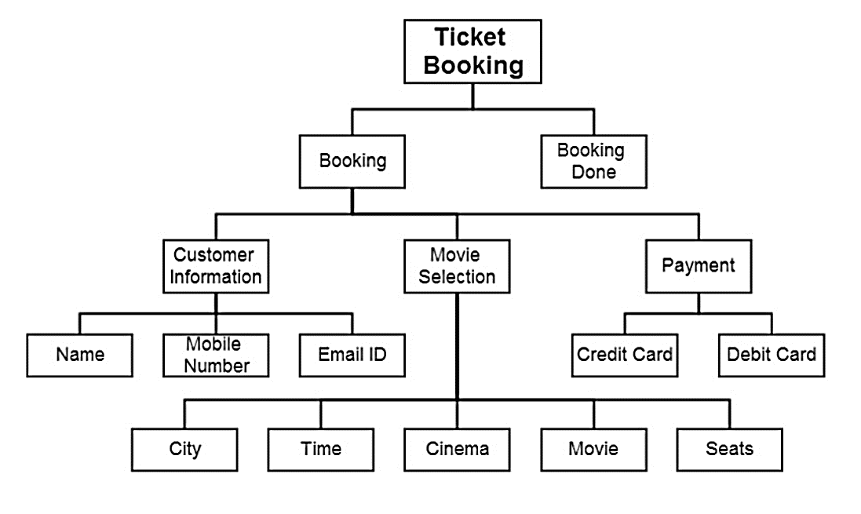

# Use Case Diagram

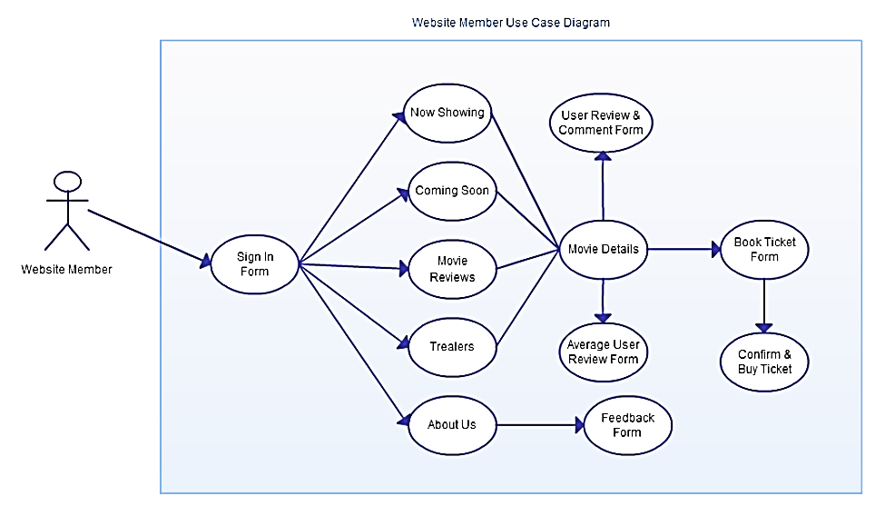

# List of modules

## 14.1) Show representation module

This module will responsible for the representation of shows categorized like **now showing, coming soon, treasures, movies, movies reviews, etc.** Also will so the past schedules of the movies shown into the theater and comments passed out on movies by the public and **ratings** with respect to stars (1-5). And also the news of a particular movie that how much it earned.

## 14.2) User Management Module

This module will manage the users who book tickets. One who wants to book a ticket s/he needs to register first; if s/he already registered, must have to log in to book a ticket and make transaction online.

From the view of the Admin it will show the statistics report of the number of the users **registered, online, booked ticket,** etc.

## 14.3) Show Booking Module

This module is for selecting the **movie show** and **seating position** and will decide the price of seating as the admin has decided for various seating positions. And before going to the payment module it will first validate to the user that s/he is logged in or not by passing massage to the **user management module,** then after it will pass a user token to payment gateway (only dem0 for this project), after success payment done will redirect to show booking module showing the status of the ticket and seat number and position what s/he have selected.

## 14.4) Payment Gateway Module

This module is designed as not as real one but will not do the real transactions this is only for completing the module for this project for fulfillment of award of degree.

It will ask the payment options like **debit card, credit card, net banking,** or from **e-wallets.** It will not going to contact to any bank you may enter fake details and it will work fine just as to book the ticket as stated already only for virtue of real payment gateways.

## 14.5) Show Management Module

This module is for admin for the purpose of **adding movies, scheduling shows,** adding **movie descriptions, treasures,**

deciding ticket/seating price for the particular shows. And can be used to show the statistics of seats booked on particular show on which particular timing of the day.

# Bibliography

* <http://www.google.com>
* <http://www.w3school.com>
* <http://begginersbook.com>
* <http://geeksforgeeks.org>
* <http://stackoverflow.com>
* <http://studytonight.com>

# Report

# Introduction

he development of web-based ticket booking system simply means creating a website to provide a service as a facility of booking cinema tickets on your computer or smart phones using internet. This service will save much time in comparison to manual works.

The application is reduced as much as possible to avoid errors while entering the data. It also provides error message while entering invalid data. No formal knowledge is needed for the user to use this system. Thus, by this al it proves it is **user-friendly**. **O**nline **M**ovie **T**icket **B**ooking System, as described in **Synopsys**, can lead to error free, secure, reliable and fast management system. It can assist the user to concentrate on their other activities rather to concentrate on record keeping. Thus, it will help organization in better utilization of resources.

Every organisation whether big or small, has challenges to overcome and managing the information of tickets, Movie, Seats, Cinema Halls, Show timings. Every Online Movie Ticket Booking System has different Movie needs; therefore, we design exclusive employee management system that are adapted to your managerial requirements. This is designed to assist in strategic planning and will help to ensure that your organization is equipped with the right level of information and details for your future goals. Also, for those busy executives who are always on the go, our system come with remote access features, which will allow you to manage your workforce anytime, at all times. This system will allow you to better manage resources.

# Abstract of the Project

The purpose of Online Movie Ticket Booking System is to automate the existing manual system by the help of computerized equipment and full-fledged computer software, fulfilling their requirements, so that their valuable data/information can be stored for a longer period with easy accessing and manipulation of the same. The required software and hardware are easily available and easy to work with.

Online Movie Ticket Booking System, as described above, can lead to error free, secure, reliable and fast management system. It can assist the user to concentrate on their other activities rather than to concentrate on record keeping. Thus, it will help organization in better utilization of resources. The organisation can maintain computerized records without redundant entries. That one need not be distracted by information that is not relevant, while being able to reach the information. Basically, the project describes how to manage for good performance and better services for the clients.

# Functionalities provided

* Provides the searching facilities based on various factors. Such as Movies, Shows, Show timings.
* To manage records of movies, schedules of shows.
* Tracks all the records of seats booked, income generated and past statistics.
* Manages the information of tickets and members registered on the system.
* A person can book a ticket only after the registration.
* Ticket charges can be paid online through net banking, debit card and credit card (**while in this project only a real scenario is built no actual payment gateway is added to receive payments**)
* While booking ticket person can choose seating positions if not already booked by another person.

# Scope of the Project

It may help in collecting perfect management in detail. In a very short time, the collection will be obvious, simple and sensible. It will help a person to know the management of passed year perfectly and vividly. It also helps in current all works relative to Online Move Ticket Booking System. It will be also reduced the cost of collecting the management & collection procedure will go on smoothly.

Our project aims at Business process automation, i.e. we have tried to computerize various processes of Online Movie Ticket Booking System.

* In computer system the person has to fill the various forms & number of copies of forms can be easily generated at a time.
* To assist the staff in capturing the effort spent on their respective working areas.
* To utilize resources in an efficient manner by increasing their productivity through automation
* The system generates types of information that can be used for various purposes.
* It satisfies the user requirement
* Be easy to understand by the user and the operator
* Be easy to operate
* Have a good user interface
* It generates the report on Movie, Tickets Cinema Halls
* Provide filter reports on Booking Customer, Seats, Show timing

# Analysis

## Feasibility Analysis

Whatever we think need not be feasible. It is wise to think about the feasibility of any problem we undertake. Feasibility is the study of impact, which happens in the organization by the development of a system. The impact can be either positive or negative. When the positives nominate the negatives, then the system is considered feasible. Here the feasibility study can be performed in two ways such as technical feasibility and Economical Feasibility.

### Technical Feasibility:

We can strongly say that it is technically feasible, since there not be much difficulty in getting required resources for the development and maintaining the system as well. All the resources needed for the development of the software as well as the maintenance of the same is available in the organization here we are utilizing the resources which are available already.

### Economic Feasibility:

Development of this application is highly economically feasible. The organization needed not spend much money for the development of the system already available. The only thing is to be don is making an environment for the development with an effective supervision. If we are doing so, we can attain the maximum usability of the corresponding resources. Even after the development, the organization will not be in condition to invest more. Therefore, the system is economically feasible.

## Data Flow Diagrams

A data flow diagram (DFD) is a graphical representation of the "flow" of data through an information system, modelling its process aspects. A DFD is often used as a preliminary step to create an overview of the system without going into great detail, which can later be elaborated.

### 0 level DFD (Context)

A context diagram is a top level (also known as "Level zero") data flow diagram. It only contains one process node ("Process 0") that generalizes the function of the entire system in relationship to external entities. DFD Layers. Draw data flow diagrams can be made in several nested layers.



### 1st level DFD

The Level 1 DFD shows how the system is divided into sub-systems (processes), each of which deals with one or more of the data flows to or from an external agent, and which together provide all of the functionality of the system as a whole.

1. **For customer/visitor**

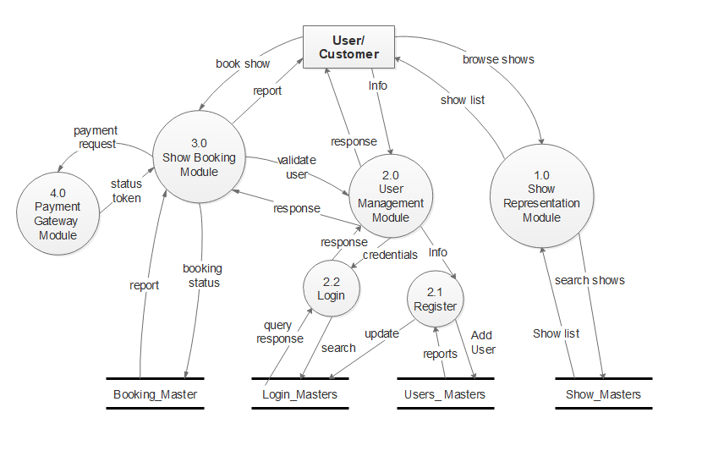**1st level DFD (a)**

1. **For Admin**

### 2nd level DFD

A level 2 data flow diagram (DFD) offers a more detailed look at the processes that make up an information system than a level 1 DFD does. It can be used to plan or record the specific makeup of a system. Here I tried to explain the whole ticket booking flow.

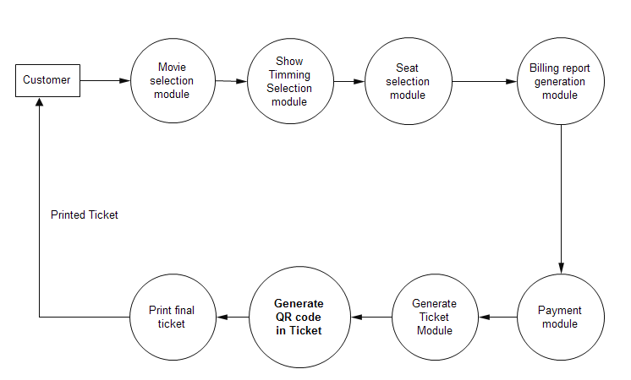

# System Modules

1. **Movie Management Module**: Used for managing the movies details like- adding new movies and their related information like – leading actors, directors and an overview of the movie which will insist a person to watch the movie ☺.
2. **Show timing Module:** Used for managing the details of show timings.
3. **Ticket Management Module:**  Used for managing the information and details of the tickets.
4. **Booking Module:** Used to book tickets
5. **Seating Module:** Used to select the seating plans by the customers
6. **Registration Module:** Used to signing up on the proposed system to access the facility of booking tickets.
7. **Login Module:** Used to login for already registered persons.
8. **Profile Management Module:** Used to manage their profiles by updating information and uploading profile pictures.
9. **Booking History Management Module:** Used to view the report of past booked tickets of a person.
10. **Changing Password Module:** Will allow a person to update their password what they want.

# Tools and technologies needed to develop the system

## Hardware:

The minimum hardware required to run Windows 7 or above operating system are comfortable to install the software tools required to develop this project.

## Software:

* **Operating System:** Windows 7, 8, 10, Linux(any)
* **IDE :** Eclipse
* **Database :** MySQL
* **Browser :** Any of chrome, Mozilla, Opera etc.
* **Web Server :** Apache Tomcat

## Technologies/Languages

* **Front :** Thymleaf,HTML, CSS, JavaScript, Ajax, jQuery and Bootstrap
* **Back-End :** Core java, Spring Core, Spring MVC, Spring Data JPA, Hibernate, Spring Security.

## Tools needed to make it online

A domain supporting to deploy java web applications with database support like:

* <http://www.godaddy.com>
* http://www.aws.com

These are the hosting sites which provide many functionalities to host the java web applications. Some of the hosting sites provides trial subdomains to test your application and then decide which plan you have to take to run your project efficiently and securely.

# Database Design

The general theme behind a database is to handle information as an integrated whole. A database is a collection of interrelated data stored with minimum redundancy to serve many users quickly and effectively. After designing input and output, the analyst must concentrate on database design or how data should be organized around user requirements. The general objective is to make information access, easy quick, inexpensive and flexible for other users. During database design the following objectives are concerned: -

* ➢ Controlled Redundancy
* ➢ Data independence
* ➢ Accurate and integrating
* ➢ More information at low cost
* ➢ Recovery from failure
* ➢ Privacy and security
* ➢ Performance
* ➢ Ease of learning and use

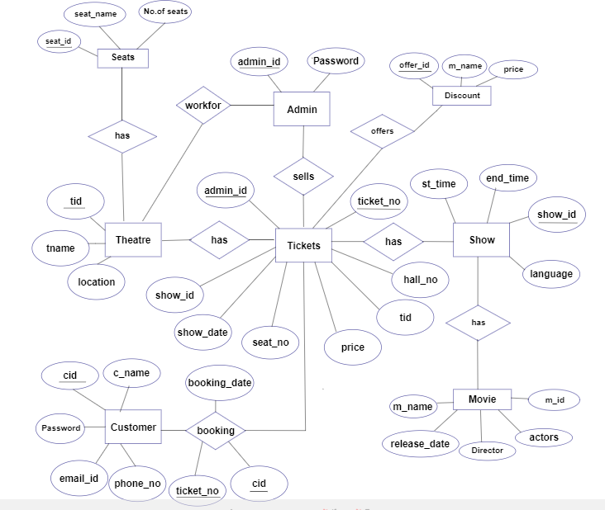

# Database Table Structures

|  |  |  |  |
| --- | --- | --- | --- |
| **Customers** | | | |
| **Column Name** | **Data Type** | **Nullable** | **Key** |
| Id | Varchar(100) | No | Primary |
| Name | Varchar(100) | No | - |
| Email | Varchar(50) | No | Unique |
| Mobile | Varchar(13) | No | Unique |
| Passwd | Varchar(200) | NO | - |
| Gender | Varchar(10) | No | - |
| Bday | Date | No | - |
| Image | Varchar(200) | No | - |
| Address | Varchar(500) | No | - |
| Pin_code | Int(11) | No | - |

|  |  |  |  |
| --- | --- | --- | --- |
| **Movies** | | | |
| **Column Name** | **Data Type** | **Nullable** | **Key** |
| M_id | bigint(20) | No | Primary |
| Title | Varchar(500) | No | Unique |
| Type | Varchar(200) | No | - |
| Language | Varchar(50) | No | - |
| Actors | Varchar(200) | No | - |
| Director | Varchar(100) | No | - |
| Description | Longtext | No | - |
| releaseDate | Date | No | - |
| Poster | Varchar(600) | No | - |

|  |  |  |  |
| --- | --- | --- | --- |
| **Shedule** | | | |
| **Column Name** | **Data Type** | **Nullable** | **Key** |
| Show_id | Int(20) | No | Primary |
| M_id | Int(20) | No | Foreign |
| Title | Varchar(100) | No | - |
| Show_time | Varchar(50) | No | - |
| Show_date | Date | No | - |
| Hall_id | Int(20) | No | - |

|  |  |  |  |
| --- | --- | --- | --- |
| **Hall** | | | |
| Column Name | Data Type | Nullable | Key |
| Hall_id | Int(20) | No | Primary |
| Hall_name | Varchar(200) | No | - |
| Hall_add | Varchar(200) | No | - |

# Flow chart

A flow chart is a pictorial representation of any dataflow. It uses different types of Symbols.

**Basic symbol of flowchart**



* **Terminal**
* **Input/output**
* **Processing**
* **Flow Lines**
* **Decision**
* **Connector**

## System Flow Chart

# Activity Diagram

# Sequence Diagram (customer)

# Collaboration Diagram (Admin)

# Use Case Diagram

## Admin

## Customer & visitor

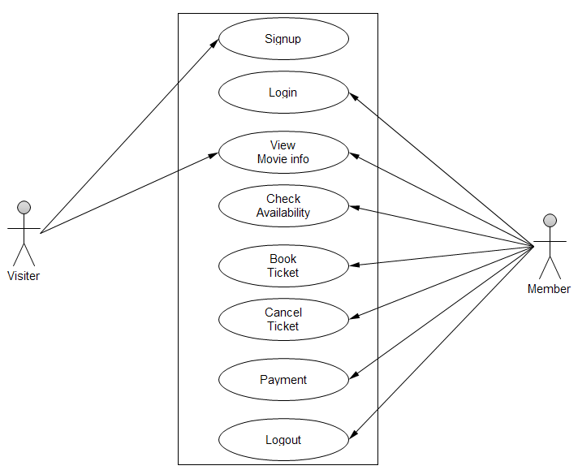

# TESTING

## Characteristics of testing:

Testing begins at the module level and works outward towards the integration of the entire computer based system. Different testing techniques are appropriate at different level of time. Testing & debugging are different activities, but debugging must be accommodated in any testing strategy. There are different model of testing.

## Black-box testing

Black-box tests are used to demonstrate that software function are operational, that input is properly accepted and output is correctly produced, and that integrity of external information is maintained.

## White-box testing

White-box tests are used to examine the procedural details. It checks the logical paths by test case. It can also checks the conditions, loops used in the software coding. It checks that loops are working correctly on defined boundary value.

## Unit testing

* In system calendar use for the book the ticket.
* In system also provide the facility for the movie information, theater information and upcoming movie information.
* In system each field have unique validation.

**Note: -** In this case Built & Fix method is used and finally tested by my Guide, (Mr. Brajesh Gautam).

# 

# Screenshots

Project Explorer

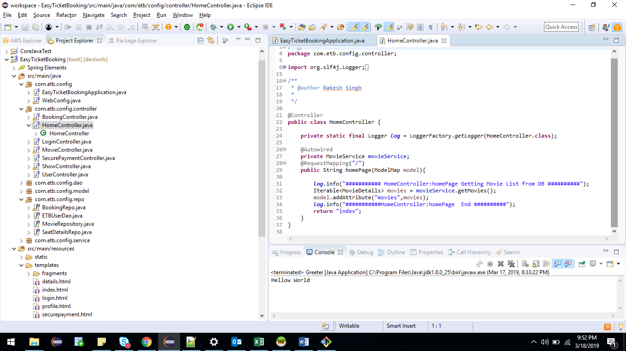

1. **Admin Module**

**Login Page: - ETB Login Page**

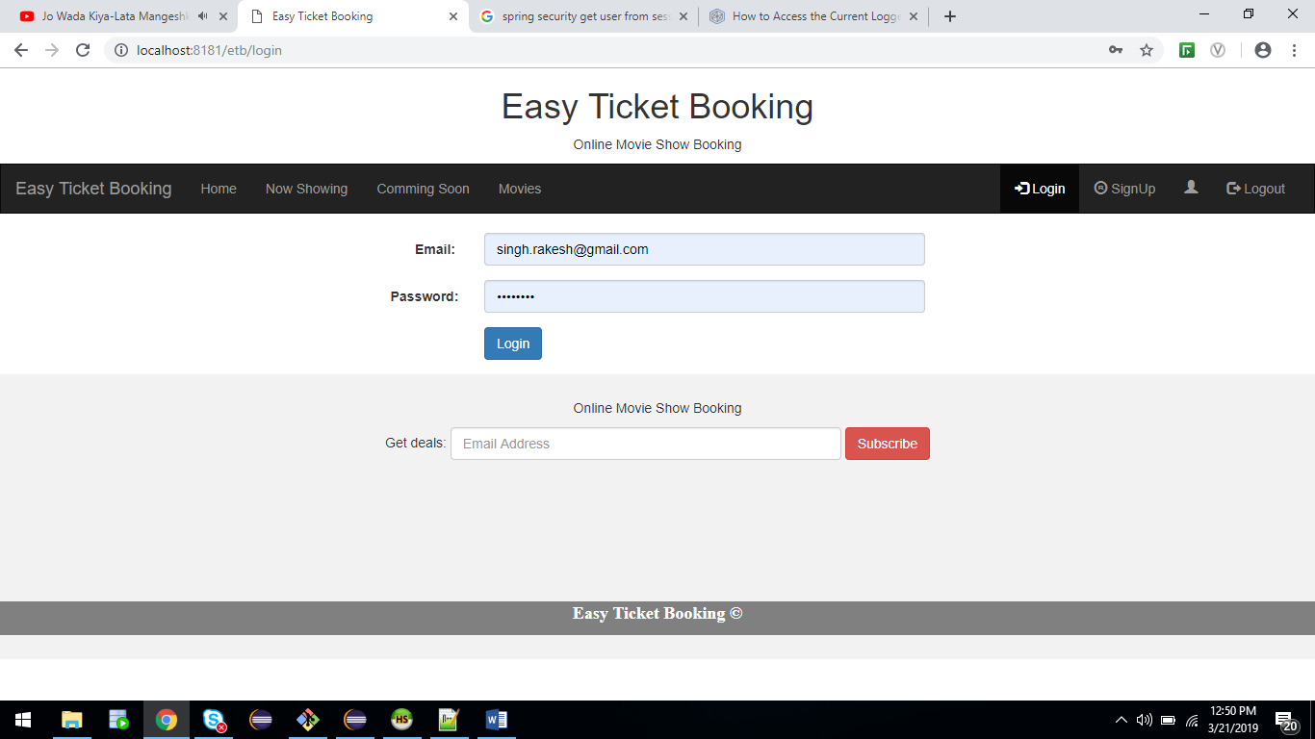

**Login page with invalid credential**

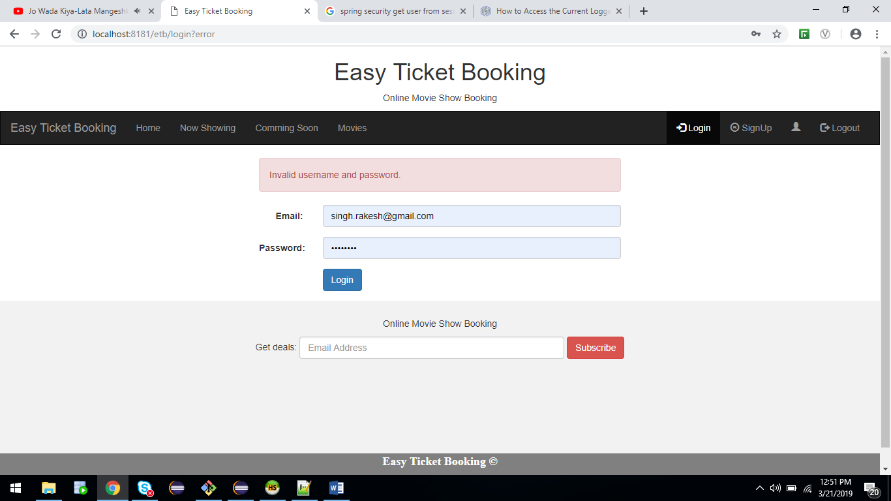

**Admin Dashboard: -**

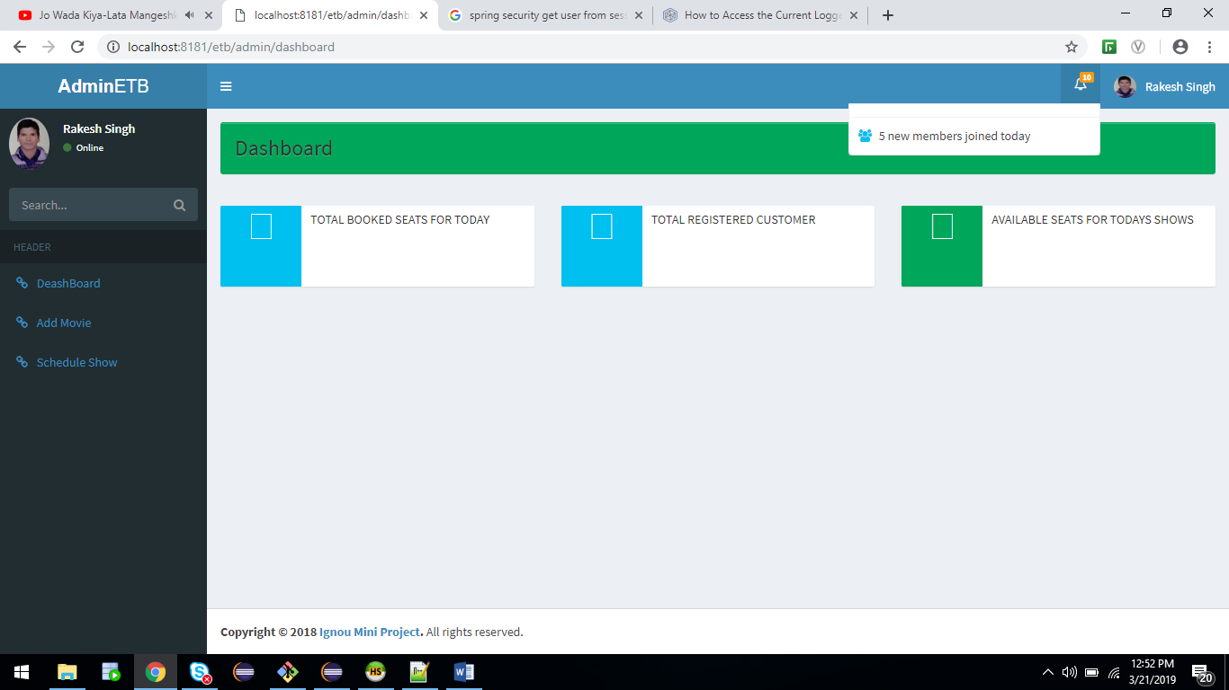

**Add movie page: -**

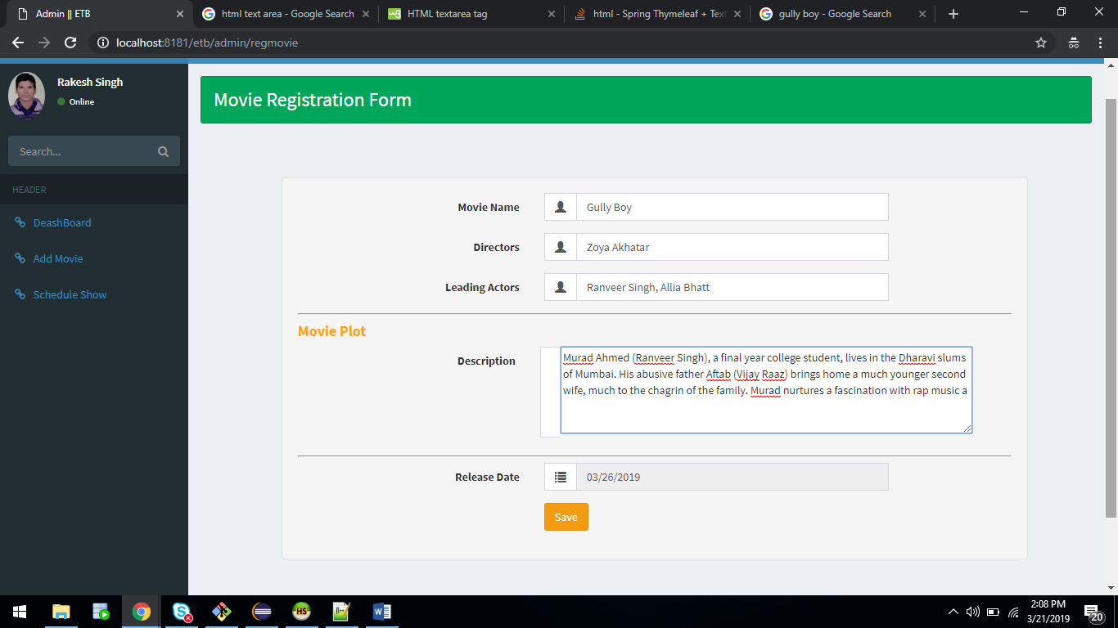

1. **User Module**

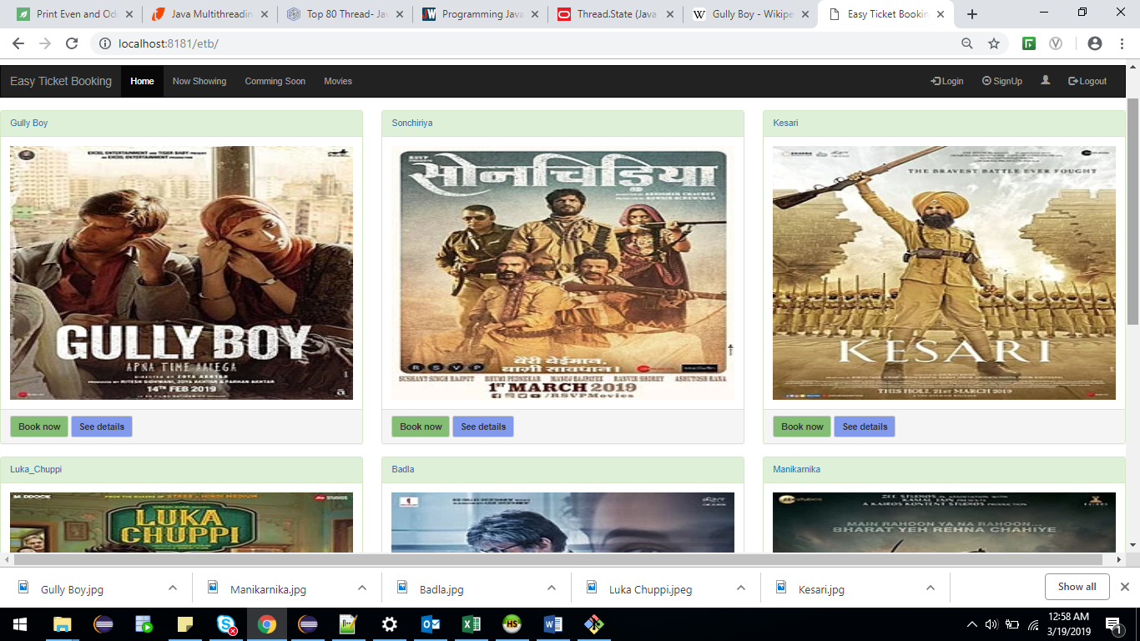

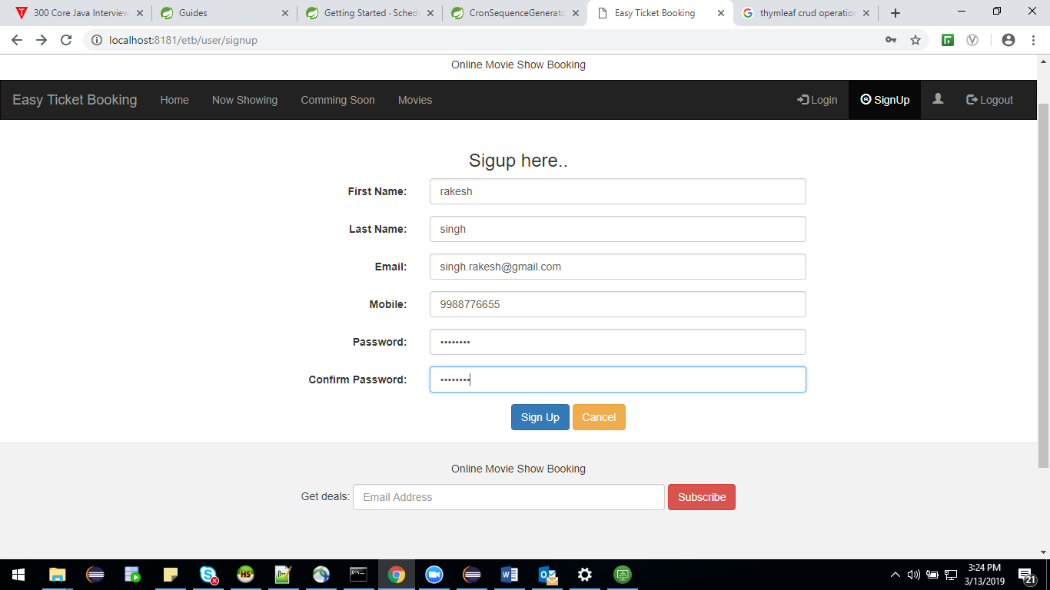

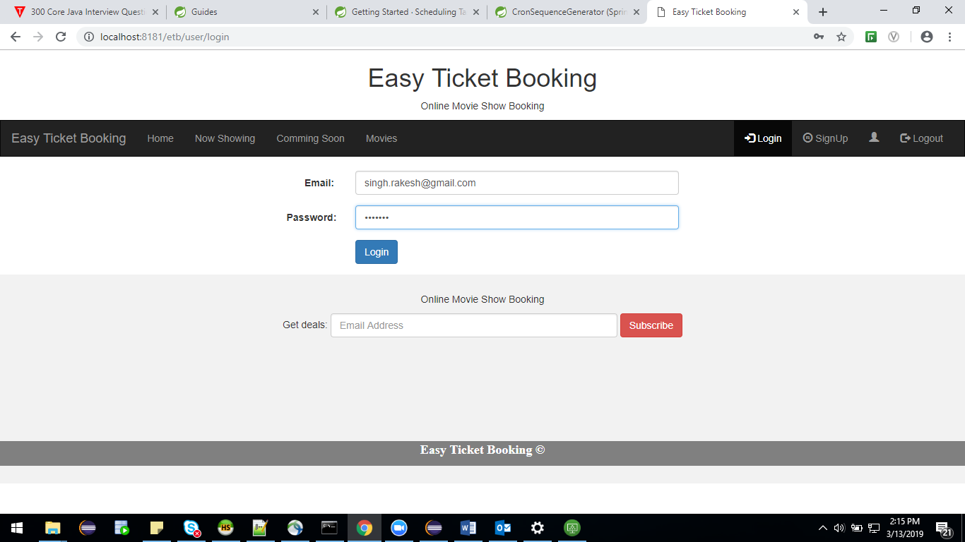

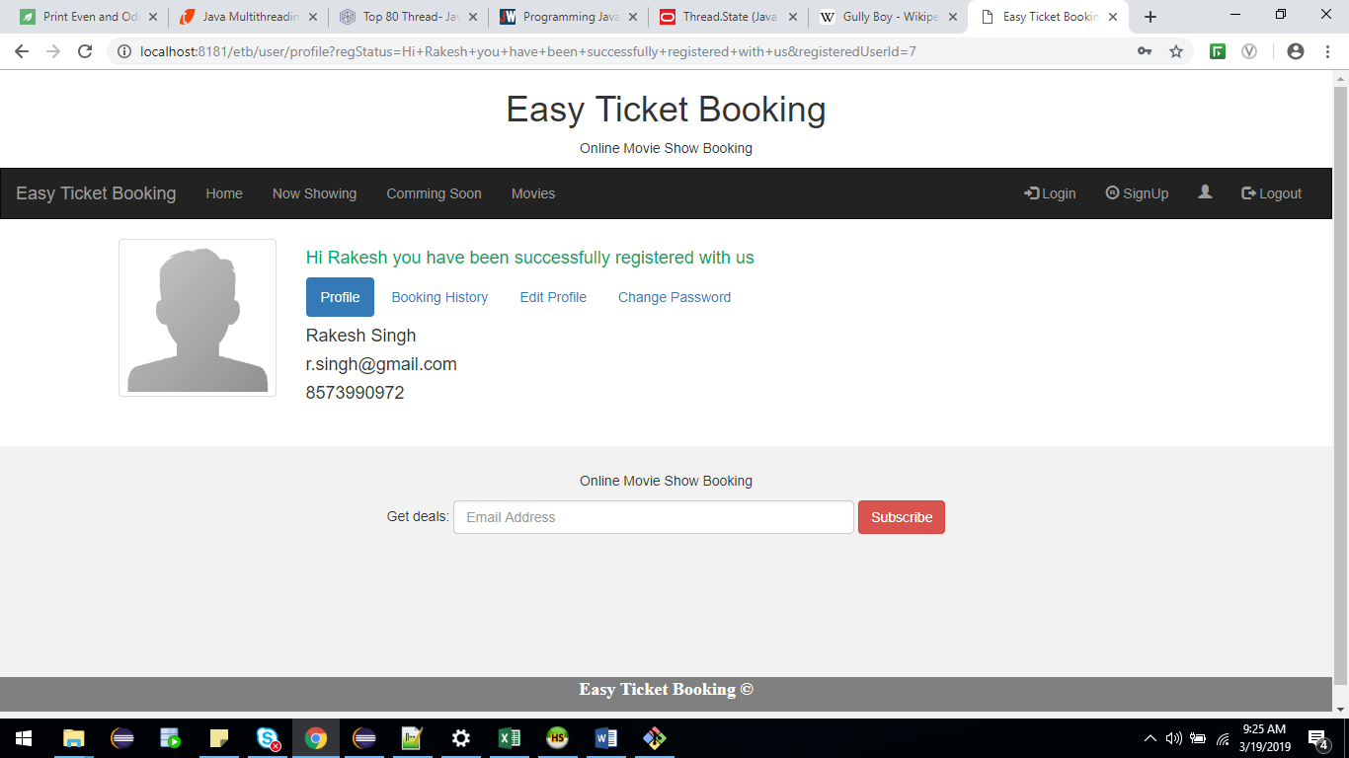

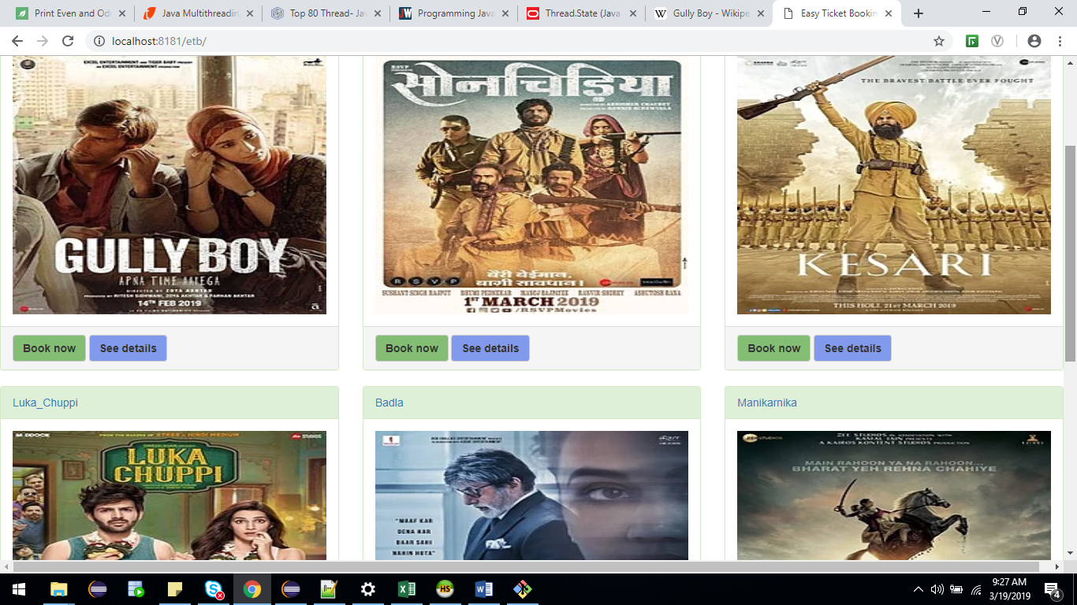

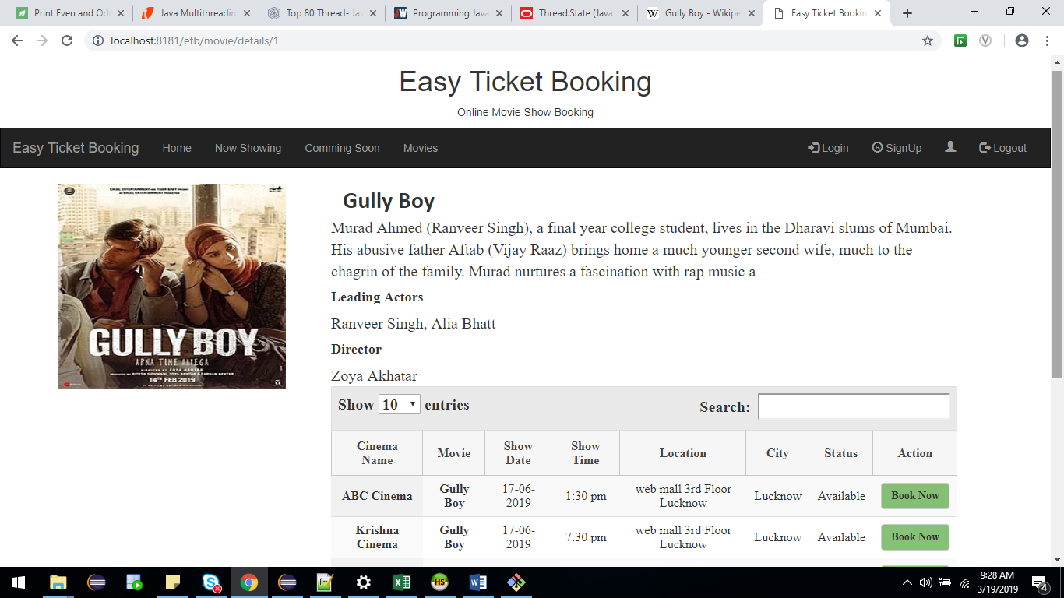

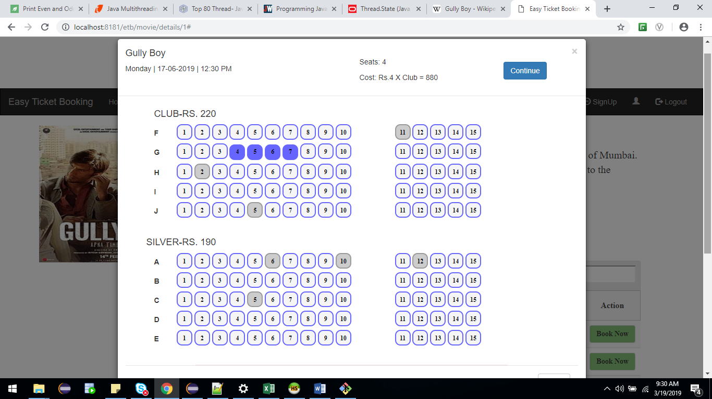

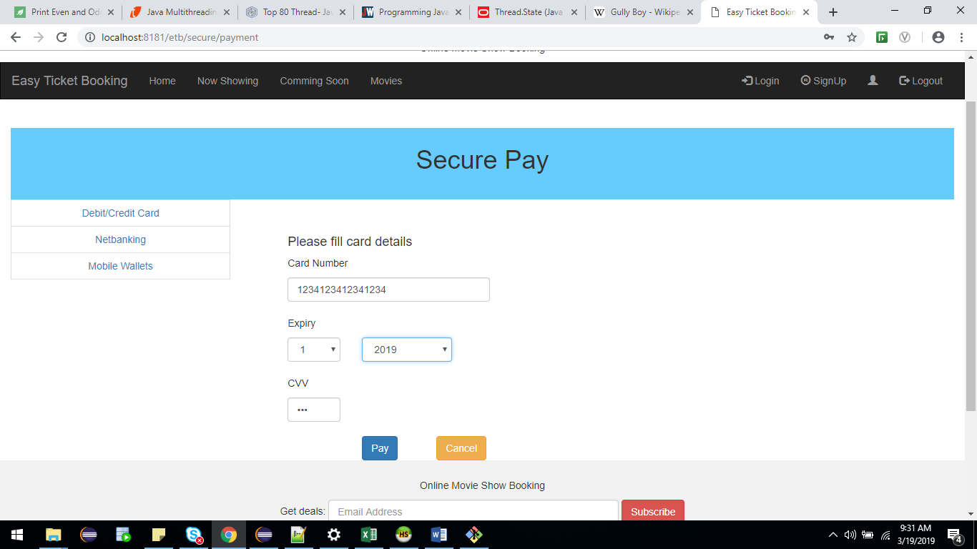

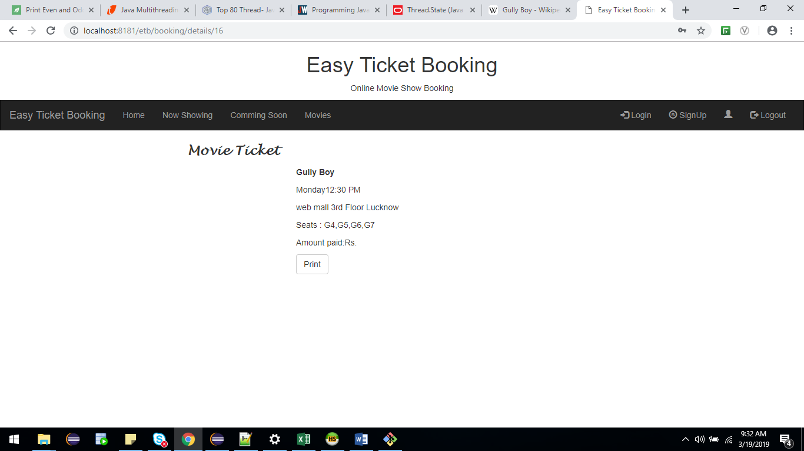

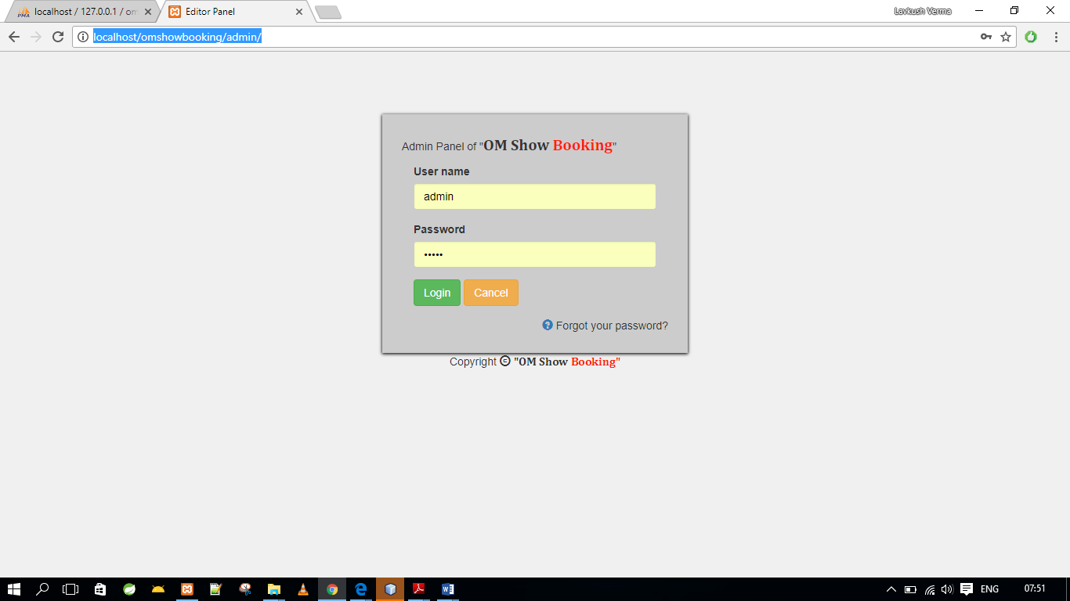**Admin Panel (**http://localhost/omshowbooking/admin/)

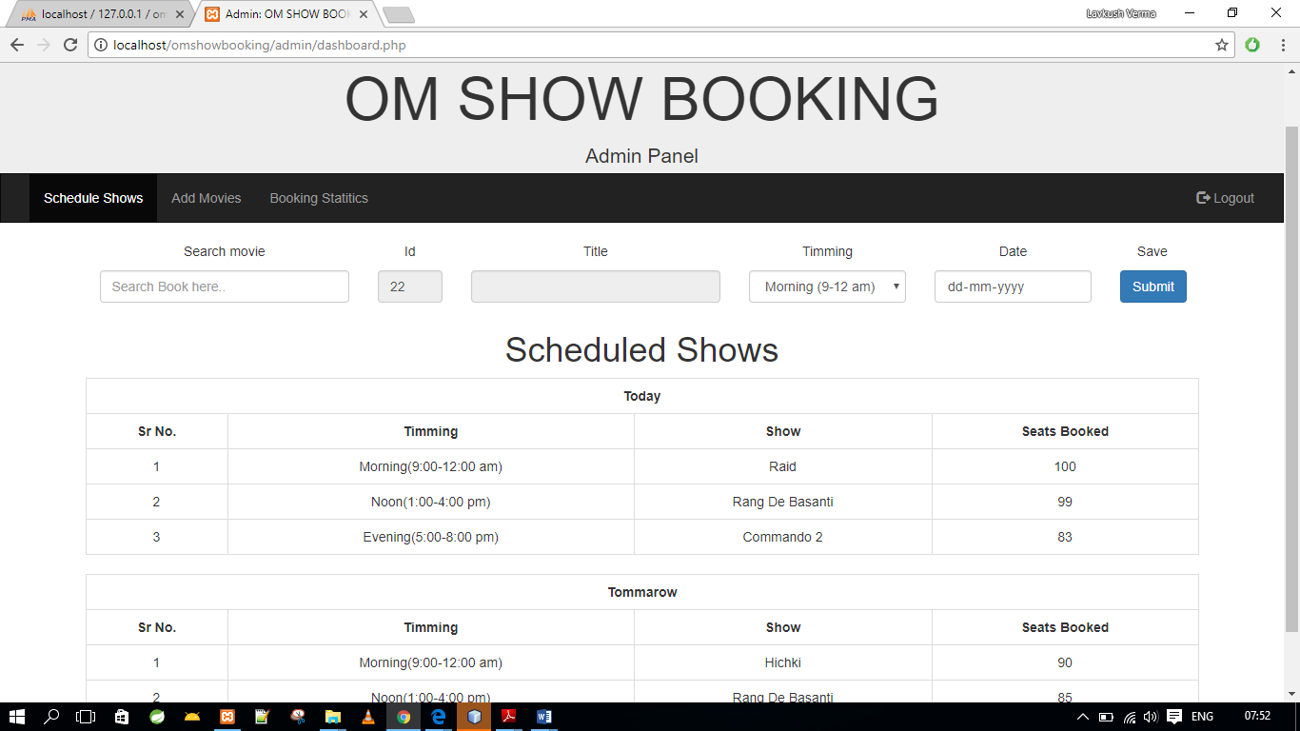

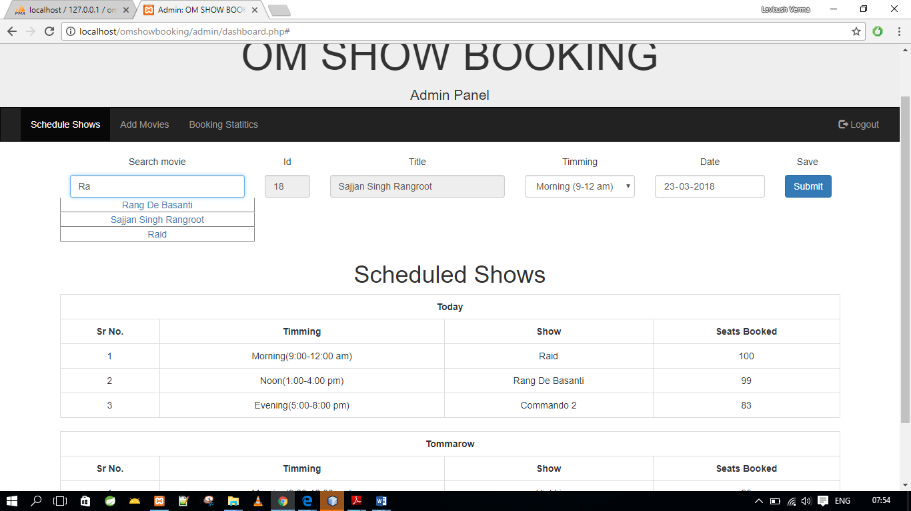

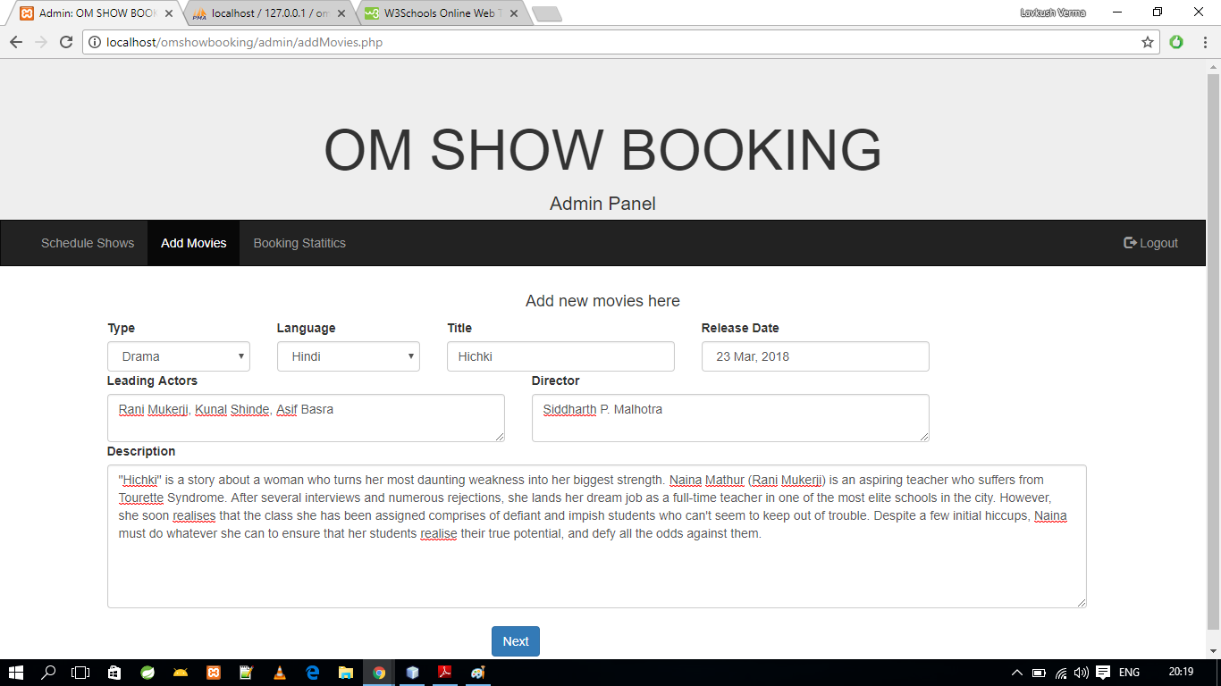

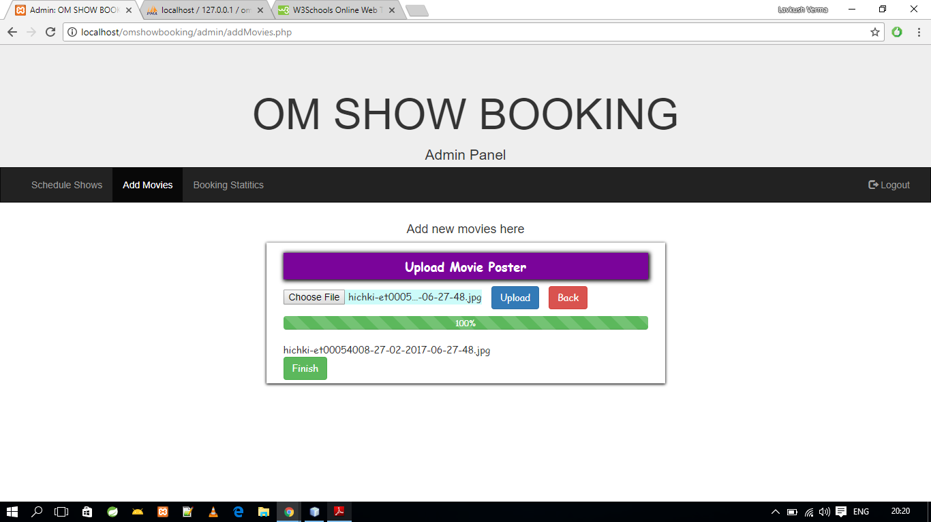

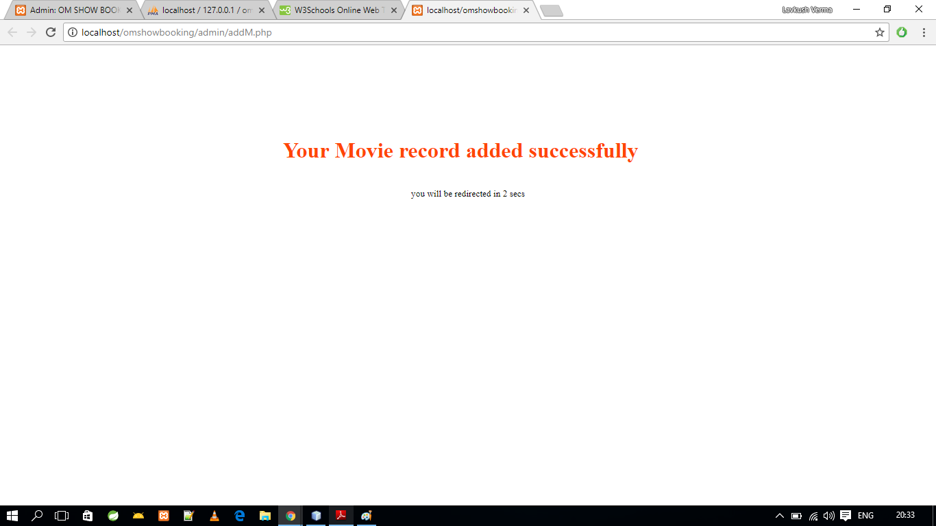

# Source Codes

**DB.php**

<?php

$servername = "localhost";

$username = "root";

$password = "";

$database = "OmShowBooking";

// Create connection

$conn = new mysqli($servername, $username, $password,$database);

// Check connection

if ($conn->connect_error) {

// die("Connection failed: " . $conn->connect_error);

header("Location: error.php?err=$conn->connect_error");

}

?>

**Head.php**

<?php

session_start();

$email = isset($_SESSION['email'])? $_SESSION['email']:'Guest';

?>

<!DOCTYPE html>

<html lang="en">

<head>

<title>OM SHOW BOOKING</title>

<meta charset="utf-8">

<meta name="viewport" content="width=device-width, initial-scale=1">

<link rel="stylesheet" href="include/bootstrap.min.css">

<script src="include/jquery.min.js"></script>

<script src="include/bootstrap.min.js"></script>

<style>

/* Remove the navbar's default rounded borders and increase the bottom margin */

.navbar {

/* margin-bottom: 50px;*/

border-radius: 0;

}

/* Remove the jumbotron's default bottom margin */

.jumbotron {

margin-bottom: 0;

height:180px !important;

}

/* Add a gray background color and some padding to the footer */

footer {

background-color: #f2f2f2;

padding: 25px;

}

</style>

</head>

<body>

<div class="jumbotron bg-info">

<div class="container text-center">

<h1>OM SHOW BOOKING</h1>

<p>Online Movie Show Booking</p>

</div>

</div>

<nav class="navbar navbar-inverse">

<div class="container-fluid">

<div class="navbar-header">

<button type="button" class="navbar-toggle" data-toggle="collapse" data-target="#myNavbar">

<span class="icon-bar"></span>

<span class="icon-bar"></span>

<span class="icon-bar"></span>

</button>

<a class="navbar-brand" href="index.php">Om Show Booking</a>

</div>

<div class="collapse navbar-collapse" id="myNavbar">

<ul class="nav navbar-nav">

<li class="active"><a href="index.php">Home</a></li>

<li><a href="nowshowing.php">Now Showing</a></li>

<li><a href="comming.php">Comming Soon</a></li>

<li><a href="movies.php">Movies</a></li>

</ul>

<?php if ($email != "Guest"){ ?>

<ul class="nav navbar-nav navbar-right">

<li><a href="profile.php"><span class="glyphicon glyphicon-user"></span> <?php echo $_SESSION['name'] ?></a></li>

<li><a href="logout.php"><span class="glyphicon glyphicon-log-out"></span> Logout</a></li>

</ul>

<?php }else{ ?>

<ul class="nav navbar-nav navbar-right">

<li><a href="login.php"><span class="glyphicon glyphicon-log-in"></span> Login</a></li>

<li><a href="signup.php"><span class="glyphicon glyphicon-registration-mark"></span> SignUp</a></li>

</ul>

<?php } ?>

</div>

</div>

</nav>

**foot.php**

<footer class="container-fluid text-center">

<p>Online Movie Show Booking</p>

<form class="form-inline">Get deals:

<input type="email" class="form-control" size="50" placeholder="Email Address">

<button type="button" class="btn btn-danger">Subscribe</button>

</form>

<div class="row text-center" style="margin-top:20px;background-color:gray;color:white;font-family: sitika small; font-size:18;font-weight:bold;">

<p>OM Show Booking &COPY;</p><small></small>

</div>

</footer>

</body>

</html>

**Index.php**

<?php include 'head.php'?>

<div class="container">

<?php include 'DB.php';

$sql = "select * from movies";

$result = $conn->query($sql);

if ($result->num_rows > 0) {

for($i=1;$i<=5;$i++){ ?>

<div class="row">

<?php for($j=1;$j<=3;$j++){ $row = $result->fetch_assoc();?>

<div class="col-sm-4">

<div class="panel panel-success">

<div class="panel-heading"><a href="details.php?m=<?php echo $row["title"]?>&id=<?php echo $row["m_id"]?>"><?php echo $row["title"]?></a></div>

<div class="panel-body">

<a href="details.php?m=<?php echo $row["title"]?>&id=<?php echo $row["m_id"]?>">

<img src="admin/posters/<?php echo $row["image"]?>" class="img-responsive" style="width: 100%" alt="Image">

</a>

</div>

<div class="panel-footer">

<a href="book.php?id=<?php echo $row["m_id"]?>" class="btn btn-default">Book now</a>

<a class="btn btn-default" href="details.php?m=<?php echo $row["title"]?>&id=<?php echo $row["m_id"]?>">See details</a>

</div>

</div>

</div>

<?php }?>

</div>

<?php }} ?>

</div><br>

<style>

.panel{}

.panel-heading{ font-family:Lucida;font-weight:bold;font-size:20px;}

</style>

<?php include 'foot.php'?>

**Singnup.php**

<?php include 'head.php'?>

<?php isset($_SESSION['email'])? header("location:profile.php"): 1;?>

<div class="container">

<div class="row">

<h3 class="text-center">Sigup here..</h3>

<div class="col-md-2"></div>

<div class="col-md-8">

<form class="form-horizontal" method="post" action="proc_signup.php" onsubmit="return check_pass()">

<div class="form-group">

<label class="control-label col-sm-4" for="name">Full Name:</label>

<div class="col-sm-8">

<input type="text" class="form-control" name="name" id="name" required placeholder="Enter Name">

</div>

</div>

<div class="form-group">

<label class="control-label col-sm-4" for="email">Email:</label>

<div class="col-sm-8">

<input type="email" class="form-control" name="email" required id="email" placeholder="Enter email">

</div>

</div>

<div class="form-group">

<label class="control-label col-sm-4" for="mobile">Mobile:</label>

<div class="col-sm-8">

<input type="tel" class="form-control" name="mobile" required id="mobile" placeholder="Enter mobile">

</div>

</div>

<div class="form-group">

<label class="control-label col-sm-4" for="pwd">New Password:</label>

<div class="col-sm-8">

<input type="password" class="form-control" name="password" id="pwd" required placeholder="Enter password">

</div>

</div>

<div class="form-group">

<label class="control-label col-sm-4" for="pwd2">Confirm Password:</label>

<div class="col-sm-8">

<input type="password" class="form-control" name="password2" id="pwd1" required placeholder="Confirm password">

</div>

</div>

<div class="form-group">

<div class="col-sm-offset-2 col-sm-10 text-center">

<button type="submit" class="btn btn-primary">Sign Up</button>

<button type="reset" class="btn btn-warning">Cancel</button>

</div>

</div>

</form>

</div>

<div class="col-md-2"></div>

</div>

</div>

<script>

function check_pass(){

var name = document.getElementById("name");

var email = document.getElementById("email");

var pwd=document.getElementById("pwd");

var pwd1=document.getElementById("pwd1");

if(name === "")alert("Name must be entered !");

if(email === "")alert("Email must be entered !");

if(pwd === "")alert("Password must be entered !");

if(pwd.value.length <8){

alert("Password should be altleast 8 characters !");

pwd.value="";

pwd1.value="";

pwd.focus();

return false;

}

if(pwd.value !== pwd1.value){

alert("password not matched!");

pwd.value="";

pwd1.value="";

pwd.focus();

return false;

}

return true;

}

</script>

<?php include 'foot.php'?>

**Proc_sign.php**

<?php include 'DB.php';

if ($_SERVER["REQUEST_METHOD"] == "POST") {

// collect value of input field

$name = $_POST['name'];

$email = $_POST['email'];

$mobile = $_POST['mobile'];

$pass = $_POST['password'];

// preparing sql

$sql = "INSERT INTO customers (name,email,mobile,passwd) VALUES ('$name', '$email', '$mobile','$pass')";

if ($conn->query($sql) === TRUE) {

// echo "New record created successfully";

// Set session variables

session_start();

$_SESSION["name"] = $name;

$_SESSION["email"] = $email;

$_SESSION["mobile"] = $mobile;

$_SESSION["image"] = "avatar.png";

header("location:index.php");

} else {

//echo "Error: " . $sql . "<br>" . $conn->error;

echo "already Registered please login";

}

$conn->close();

}

?>

**login.php**

<?php include 'head.php'?>

<?php isset($_SESSION['email'])? header("location:profile.php"): 1;?>

<div class="container">

<div class="row">

<div class="col-md-3"></div>

<div class="col-md-6">

<form class="form-horizontal" method="post" action="proc_login.php">

<div class="form-group">

<label class="control-label col-sm-2" for="email">Email:</label>

<div class="col-sm-10">

<input type="email" class="form-control" name="username" id="email" placeholder="Enter email">

</div>

</div>

<div class="form-group">

<label class="control-label col-sm-2" for="pwd">Password:</label>

<div class="col-sm-10">

<input type="password" class="form-control" name="password" id="pwd" placeholder="Enter password">

</div>

</div>

<div class="form-group">

<div class="col-sm-offset-2 col-sm-10">

<button type="submit" class="btn btn-default btn-primary">Login</button>

</div>

</div>

</form>

</div>

<div class="col-md-3"></div>

</div>

</div>

<?php include 'foot.php'?>

**Proc_login.php**

<?php include 'DB.php'?>

<?php

if ($_SERVER["REQUEST_METHOD"] == "POST") {

// collect value of input field

$username = $_POST['username'];

$pass= $_POST['password'];

$sql = "select * from customers where email = '$username'";

$result = mysqli_query($conn, $sql);

$row = mysqli_fetch_row($result);

if ($row[4] == $pass) {

//echo 'success';

$id = $row[0];

$name = $row[1];

$email = $row[2];

$mobile = $row[3];

$image = $row[5];

session_start();

$_SESSION["name"] = $name;

$_SESSION["email"] = $email;

$_SESSION["mobile"] = $mobile;

if ($image == "yes") {

$_SESSION["image"] = $email . ".jpg";

} else {

$_SESSION["image"] = "avatar.png";

}

header("location:index.php");

} else {

echo '<h1 style="margin-top:10%;margin-left:30%;color:orangered;">Your credentials not matched<br> Please Login again</h1>';

header("refresh:2; url=login.php");

}

mysqli_close($conn);

}

**Profile.php**

<?php include 'head.php'?>

<?php include 'DB.php'?>

<?php

isset($_SESSION['email'])? :header("location:login.php");

$email= $_SESSION['email'];

$sql = "select * from customers where email = '$email'";

$result = mysqli_query($conn, $sql);

$row = mysqli_fetch_row($result);

$name = $row[1];

$mobile=$row[3];

$gender = $row[6];

$bday = $row[7];

$image=$_SESSION['image'];

?>

<style>

.dp{

height:150px;

width:150px;

}

.dp { position: relative;}

.image {

opacity: 1;

display: block;

width: 100%;

height: auto;

transition: .5s ease;

backface-visibility: hidden;

}

.middle {

transition: .5s ease;

opacity: 0;

position: absolute;

top: 50%;

left: 50%;

transform: translate(-50%, -50%);

-ms-transform: translate(-50%, -50%)

}

.dp:hover .image {

opacity: 0.3;

}

.dp:hover .middle {

opacity: 1;

}

.glyphicon-remove{color:red}

.glyphicon-ok{color:#00cc00}

.red{border:1px solid red;box-shadow:1px 1px 1px 1px #fca9a9;color:red}

.green{border:1px solid green;box-shadow:1px 1px 1px 1px #99ff99;color:green}

.yellow{border:1px solid yellow;box-shadow:1px 1px 1px 1px #fbfbac;}

</style>

<div class="container ">

<div class="col-sm-2 ">

<div class="dp">

<img src="uploads/<?php echo $image;?>" class="image img-thumbnail img-responsive">

<div class="middle">

<div class="text"><a class="btn btn-default" href="dpupload.php" >Change</a></div>

</div>

</div><br><br>

<div class="col-sm-12" style="position:initial">

<ul class="list-unstyled">

<li class="h4"><?php echo $name ?></li>

</ul>

</div>

</div>

<div class="col-sm-8">

<ul class="nav nav-pills">

<li class="active"><a data-toggle="pill" href="#profile">Profile</a></li>

<li><a data-toggle="pill" href="#bookingHistory">Booking History</a></li>

<li><a data-toggle="pill" href="#editProfile" onclick="f()">Edit Profile</a></li>

<li><a data-toggle="pill" href="#chngPasswd">Change Password</a></li>

</ul>

<div class="tab-content">

<div id="profile" class="tab-pane fade in active">

<p class="h4"> <i class="glyphicon glyphicon-user"></i> <?php echo $name?></p>

<p class="h4"><i class="glyphicon glyphicon-envelope"></i> <?php echo $email?></p>

<p class="h4"> <i class="glyphicon glyphicon-phone"></i> <?php echo "+91".$mobile?></p>

<p class="h4"><i class="glyphicon glyphicon-calendar"></i> <?php echo $bday?></p>

</div>

<div id="bookingHistory" class="tab-pane fade">

<h3>Menu 1</h3>

<p>Ut enim ad minim veniam, quis nostrud exercitation ullamco laboris nisi ut aliquip ex ea commodo consequat.</p>

</div>

<div id="editProfile" class="tab-pane fade">

<form method="post" action="profUpdate.php">

<div class="row"><br>

<div class="col-sm-6">

<div class="col-sm-12 input-group"><span class="input-group-addon" ><i class="glyphicon glyphicon-user"></i></span>

<input class="form-control " type="text" name="name" value="<?php echo $name?>"/></div><br>

<div class="col-sm-12 input-group"><span class="input-group-addon" ><i class="glyphicon glyphicon-envelope"></i></span>

<input class="form-control" disabled type="text" name="email" value="<?php echo $email?>"/></div><br>

<div class="col-sm-12 input-group"> <span class="input-group-addon" ><i class="glyphicon glyphicon-phone"></i>+91</span>

<input class="form-control " type="text" name="mobile" value="<?php echo $mobile?>"/></div><br>

</div>

<div class="col-sm-6">

<div class="col-sm-12 input-group"><span class="input-group-addon" ><i class="glyphicon glyphicon-user"></i></span>

<select id="gender" name="gender" class="form-control" value="<?php echo $gender?>">

<option ><?php echo $gender?></option>

<option id="Male" value="Male">Male</option>

<option id="Female" value="Female">Female</option>

</select></div><br>

<div class="col-sm-12 input-group"><span class="input-group-addon" ><i class="glyphicon glyphicon-calendar"></i></span>

<input class="form-control" type="date" name="bday" value="<?php echo $bday?>"/></div><br>

<div class="col-sm-12">

<input class=" btn btn-danger" type="submit" value="Update"/></div><br>

</div>

</div>

</form>

</div>

<div id="chngPasswd" class="tab-pane fade col-sm-6"><br>

<form method="post" action="chngpwd.php">

<div class="input-group" data-toggle="tooltip" data-placement="top" title="Current Password">

<span class="input-group-addon" ><i class="glyphicon glyphicon-lock"></i></span>

<input type="password" class="form-control" name="currentpassword" required placeholder=" Current Password....">

<span class="glyphicon glyphicon-ok form-control-feedback hidden" ></span>

</div><br>

<div class="input-group" data-toggle="tooltip" data-placement="top" title="New Password">

<span class="input-group-addon pwd" ><i class="glyphicon glyphicon-lock"></i></span>

<input type="password" class="form-control pwd" name="newpassword" id="pwd" required placeholder=" New Password....">

<span class="glyphicon glyphicon-ok form-control-feedback hidden" id="p"></span>

</div><br>

<div class="input-group" data-toggle="tooltip" data-placement="top" title="Confirm Password">

<span class="input-group-addon pwd1" ><i class="glyphicon glyphicon-lock"></i></span>

<input type="password" class="form-control pwd1" name="password1" id="pwd1" required placeholder=" Confirm Password....">

<span class="glyphicon glyphicon-ok form-control-feedback hidden" id="p1"></span>

</div><br>

<div class="input-group" data-toggle="tooltip" data-placement="top" title="Verify">

<input type="submit" class="btn btn-danger form-control" value="Verify">

</div><br>

</form>

</div>

</div>

</div>

<script>

$(document).ready(function(){

$("#pwd").on("keypress",function(){

if($("#pwd").val().length <5){$(".pwd").removeClass("green yellow").addClass("red");

$("#p").removeClass("hidden glyphicon-ok").addClass("glyphicon-warning-sign");}

else if($("#pwd").val().length <7){$(".pwd").removeClass("green red").addClass("yellow");

$("#p").removeClass("hidden glyphicon-ok").addClass("glyphicon-warning-sign");}

else if($("#pwd").val().length <9){$(".pwd").removeClass("red yellow").addClass("green");

$("#p").removeClass("hidden glyphicon-warning-sign").addClass("glyphicon-ok");}

});

$("#pwd1").on("keyup",function(){

if($("#pwd").val()!= $("#pwd1").val()){$(".pwd1").removeClass("green").addClass("red");

$("#p1").removeClass("hidden glyphicon-ok").addClass("glyphicon-remove");}

else{$(".pwd1").removeClass("red").addClass("green");

$("#p1").removeClass("hidden glyphicon-remove").addClass("glyphicon-ok");

}

});

});

</script>

</div>

**profUpdate.php**

<?php include 'DB.php'?>

<?php

session_start();

$email = $_SESSION['email'];

if ($_SERVER["REQUEST_METHOD"] == "POST") {

// collect value of input field

$name = $_POST['name'];

$mobile = $_POST['mobile'];

$gender = $_POST['gender'];

$bday = $_POST['bday'];

$sql="update customers set name='$name',mobile='$mobile',gender='$gender',bday='$bday' where email='$email' ";

if ($conn->query($sql) === TRUE) {

$_SESSION["name"] = $name;

$_SESSION["mobile"] = $mobile;

echo '<h1 style="margin-top:10%;margin-left:30%;color:Green;">Profile Updated Successfully</h1>';

header("refresh:1; url=profile.php");

}

else {echo '<h1 style="margin-top:10%;margin-left:30%;color:red;">Failed to update profile</h1>';

// header("refresh:1; url=profile.php");

}

}

**Details.php**

<?php

include 'DB.php';

include 'head.php';

$id = $_GET['id'];

$query = "select * from movies where m_id = $id";

$result = $conn->query($query);

$row = $result->fetch_assoc();

?>

<script>

$(document).ready(function(){

$('.seat').click(function(){

$(this).removeClass("available").addClass("selected");

});

});

</script>

<div class="container">

<div class="row">

<div class="col-md-3 row ">

<div class="row col-sm-13 ">

<img class="img img-responsive poster" src="admin/posters/<?php echo $row["image"]?>">

</div><br>

<div class="row lnkbar">

<div class="col-md-3"></div>

<div class="col-md-2">

<a href="book.php?id=<?php echo $row["m_id"]?>" class="btn btn-default">Book now</a>

</div>

</div>

</div>

<div class="col-md-9">

<div class="row">

<div class="col-md-1"></div>

<div class="col-md-11 title "> &nbsp;&nbsp;<?php echo $row["title"]?> </div>

</div>

<div class="row">

<div class="col-md-1"></div>

<div class="col-md-11 description">

<div class="row"> <?php echo $row["description"]?></div>

<div class="row"> <h4><b>Leading Actors </b></h4><?php echo $row["actor"]?></div>

<div class="row"> <h4><b>Director </b></h4><?php echo $row["director"]?></div>

<div class="row">

<table class="table table-bordered table-responsive">

<th colspan="6">Shows</th>

<tr>

<td>Day</td>

<td>Date</td>

<td>Time</td>

<td>Address</td>

<td>Status</td>

<td></td>

</tr>

<tr>

<th>Friday</th>

<th>19 Mar,2018</th>

<th>1:00 - 4:00 PM</th>

<th>Janak Cinema,New Delhi</th>

<th>139 booked 200</th>

<th> <button type="button" class="btn btn-default" data-toggle="modal" data-target="#myModal">Book Now</button></th>

</tr>

<tr>

<th>Saturday</th>

<th>20 Mar,2018</th>

<th>5:00 - 8:00 PM</th>

<th>Spice Cinema, Noida</th>

<th>107 booked of 250</th>

<th> <button type="button" class="btn btn-default" data-toggle="modal" data-target="#myModal">Book Now</button></th>

</tr>

</table>

</div>

</div>

</div>

</div>

</div>

<div class="modal fade" id="myModal" role="dialog">

<div class="modal-dialog modal-lg">

<!-- Modal content-->

<div class="modal-content">

<div class="modal-header">

<button type="button" class="close" data-dismiss="modal">&times;</button>

<div class="row">

<div class="col-sm-6">

<h4 class="modal-title">Commando 2</h4>

<h5>Sat, Mar 20, 5:00 PM |Hindi|- Spice Cinema, Noida</h5>

</div>

<div class="col-sm-6">

<p>Seats: 3</p>

<p>Cost: Rs.120x3= Rs.360</p>

<button class="btn btn-primary" style="float:right;margin-top: -50px;margin-right:60px;">Continue</button>

</div>

</div>

</div>

<div class="modal-body">

<div class="row" style="padding:0px 0px 0px 40px;">

<div class="col-sm-5" style="padding-left:30px;">

<?php for($j=1;$j<=10;$j++){ if($j===6) {echo "<div style='height:10px;'></div>";} ?>

<div class="row">

<?php for($i=1;$i<=10;$i++){ ?>

<div class="seatcover"><a href="#"><div class="seat <?php if($j%$i<=2){echo "booked";}else{echo "available";} ?>"><?php echo $i ?></div></a> </div>

<?php } ?>

</div>

<?php } ?>

</div>

<div class="col-sm-1" style="padding:0px;">

<div class="seatcover"><a href="#"><div class="seat booked"><?php echo '11' ?></div></a> </div>

<div class="seatcover"><a href="#"><div class="seat booked"><?php echo '12' ?></div></a> </div>

</div>

<div class="col-sm-5">

<div class="row">

<?php for($i=13;$i<=22;$i++){ ?>

<div class="seatcover"><a href="#"><div class="seat <?php if($i%$j+2<=3){echo "booked";}else{echo "available";} ?>"><?php echo $i ?></div></a> </div>

<?php } ?>

</div>

<?php for($j=1;$j<=9;$j++){ if($j===5) {echo "<div style='height:10px;'></div>";} ?>

<div class="row">

<?php for($i=11;$i<=20;$i++){ ?>

<div class="seatcover"><a href="#"><div class="seat <?php if($i%$j+2<=3){echo "booked";}else{echo "available";} ?>"><?php echo $i ?></div></a> </div>

<?php } ?>

</div>

<?php } ?>

</div>

</div>

<div class="row" style="margin-top:30px;">

<div class="col-sm-2"></div>

<div class="col-sm-8 bg-danger text-center " style="font-size:20px;font-weight:bold">All Eyes to This Side</div>

<div class="col-sm-2"></div>

</div>

</div>

<div class="modal-footer">

<button type="button" class="btn btn-default" data-dismiss="modal">Close</button>

</div>

</div>

</div>

</div>

<style>

.seatcover{display:inline-block;padding:0px;padding-bottom:7px;}

.seatcover a{color:black;text-decoration:none;}

.seat{height:30px;width:30px;border-radius:10px;

text-align: center; font-size:12px;

font-weight:bold;font-family:sitika small;

line-height: 28px;

}

.available{border:2px solid #6666ff;background-color:whitesmoke;}

.available:hover{background-color: #6666ff;}

.selected{background-color: #6666ff;}

.booked{border:2px solid #999999;background-color: #cccccc;}

.title{font-family: Calibri;font-size: 30px;font-weight: bold;}

.description{font-family: Lucid Sans;font-size: 20px;font-weight:normal;}

.poster{height:100%;width:100%; }

.lnkbar a {font-family:Sans;font-size:18px;}

.releaseDate{font-family: Calibri;font-size:20px;font-weight:bold;}

th,td{text-align: center;}

</style>

</div>

<?php include 'foot.php'?>

**dpUpdate.php**

<?php include 'DB.php'?>

<?php

session_start();

ini_set('upload_max_file_size', '500M');

ini_set('post_max_size', '1024M');

ini_set('memory_limit','5120M');

ini_set('max_input_time',300);

ini_set('max_execution_time',300);

$filename = $_SESSION['email'].".jpg";

$target_dir = "uploads/";

//$target_file = $target_dir . basename($_FILES["myfile"]["name"]);

$target_file = $target_dir .$filename;

$uploadOk = 1;

$imageFileType = strtolower(pathinfo($target_file,PATHINFO_EXTENSION));

// Check if image file is a actual image or fake image

if(isset($_POST["submit"])) {

$check = getimagesize($_FILES["myfile"]["tmp_name"]);

if($check !== false) {

echo "File is an image - " . $check["mime"] . ".";

$uploadOk = 1;

} else {

echo "File is not an image.";

$uploadOk = 0;

}

}

// Check file size

if ($_FILES["myfile"]["size"] > 500000) {

echo "Sorry, your file is too large.";

$uploadOk = 0;

}

// Allow certain file formats

if($imageFileType != "jpg" && $imageFileType != "png" && $imageFileType != "jpeg"

&& $imageFileType != "gif" ) {

echo "Sorry, only JPG, JPEG, PNG & GIF files are allowed.";

$uploadOk = 0;

}

// Check if $uploadOk is set to 0 by an error

if ($uploadOk == 0) {

echo "Sorry, your file was not uploaded.";

// if everything is ok, try to upload file

} else {

if (move_uploaded_file($_FILES["myfile"]["tmp_name"], $target_file)) {

echo "The file ".$target_file . " has been uploaded.";

$email = $_SESSION['email'];

$sql="update customers set image='yes' where email='$email' ";

if ($conn->query($sql) === TRUE) {

$_SESSION["image"] = $email.".jpg";

echo "db also updated";

header("refresh:2; url=profile.php");

}

else echo "failed to update dp";

} else {

echo "Sorry, there was an error uploading your file.";

}

}

?>

**dpUpload.php**

<?php include 'head.php'?>'

<div class="container">

<script>

$(document).ready(function(){

$('#ImageFile').change(function(){

$('#uploadbtn').css('visibility','visible');

});

$('#uploadbtn').click(function(){

// $(this).hide();

});

$('form').on('submit',function(event){

event.preventDefault();

var formData = new FormData($('form')[0]);

$('.progress').css('display','block');

$.ajax({

xhr : function(){

var xhr = new window.XMLHttpRequest();

xhr.upload.addEventListener('progress',function(e){

if(e.lengthComputable) {

console.log('Bytes loaded: ' + e.loaded);

console.log('Total size : ' + e.total);

console.log('Percentage uploaded: '+ (e.loaded/e.total)*100);

var percent = Math.round((e.loaded/e.total)*100);

$('#progressBar').attr('aria-valuenow',percent).css('width',percent+'%').text(percent + '%');

if(percent==100)

{

$('#rdbtn').css('visibility','visible');

}

}

});

return xhr;

},

type : 'POST',

url : 'dpupdate.php',

data : formData,

processData : false,

contentType : false,

success : functio

//show_dp()

alert("File Uploaded !");

});

});

});

});

function show_dp()

{

// $('#area').html("<img id=\"newimg\" class=\"img img-responsive\" src=\"dpextract.jsp?email=<%=session.getAttribute("email")%>\">\n\

// <a href=\"profile.jsp\" class=\"btn btn-success\" style=\"margin-left:50px;\">OK</a>");

}

</script>

<style>

#newimg{border:1px solid gray;}

.main-div{box-shadow:0px 1px 5px black;

background:white;

padding:5px 25px;}

#ImageFile{background: #ccfbf9}

#area{font-family:cursive;}

</style>

<div style="font-family:cursive;">

<div class="row">

<div class="col-sm-3 col-md-3" ></div>

<div class="col-sm-6 col-md-6 main-div" >

<div style="background: #7a049a;color:white;width:100%;box-shadow:1px 1px 8px 1px black;">

<p class="h4 text-center" style="font-weight:bold;padding:10px;">Profile Picture Upload</p>

</div>

<form name="form" method="post" enctype="multipart/form-data" action="dpupdate.php">

<ul class="list-inline">

<li><input type="file" name="myfile" id="ImageFile" accept="image/*" /></li>

<li><input id="uploadbtn" class="btn btn-primary" type="submit" value="Upload" /></li>

<li><button class="btn btn-danger" onclick="window.location.reload()">Refresh</button></li>

</ul>

</form>

<div class="progress" style="display:none;">

<div id="progressBar" class="progress-bar progress-bar-success progress-bar-striped" role="progressbar"

aria-valuenow="0" aria-valuemin="0" aria-valuemax="100" style="width:0%">

0% Complete (success)

</div>

</div>

<div id="area">

</div>

</div>

<div class="col-sm-3 col-md-3" ></div>

</div>

</div>

</div>

**Chngpwd.php**

<?php include 'DB.php'?>

<?php

session_start();

if ($_SERVER["REQUEST_METHOD"] == "POST") {

// collect value of input field

$current = $_POST['currentpassword'];

$new= $_POST['newpassword'];

$username = $_SESSION['email'];

$sql = "select * from customers where email = '$username'";

$result = mysqli_query($conn, $sql);

$row = mysqli_fetch_row($result);

if ($row[4] == $current) {

$sql1="update customers set passwd = '$new' where email='$username'";

if ($conn->query($sql1) === TRUE) {

echo '<h1 style="margin-top:10%;margin-left:30%;color:Green;">Password Updated Successfully</h1>';

header("refresh:1; url=profile.php");

}

else {echo '<h1 style="margin-top:10%;margin-left:30%;color:orangered;">failed to update password try again</h1>';}

} else {

echo '<h1 style="margin-top:10%;margin-left:30%;color:orangered;">Current Password not matched<br> Please Login again</h1>';

header("refresh:2; url=profile.php");

}

mysqli_close($conn);

}

**Movies.php**

<?php

session_start();

$email = isset($_SESSION['email'])? $_SESSION['email']:'Guest';

?>

<!DOCTYPE html>

<html lang="en">

<head>

<title>OM SHOW BOOKING</title>

<meta charset="utf-8">

<meta name="viewport" content="width=device-width, initial-scale=1">

<link rel="stylesheet" href="include/bootstrap.min.css">

<script src="include/jquery.min.js"></script>

<script src="include/bootstrap.min.js"></script>

<style>

/* Remove the navbar's default rounded borders and increase the bottom margin */

.navbar {

/* margin-bottom: 50px;*/

border-radius: 0;

}

/* Remove the jumbotron's default bottom margin */

.jumbotron {

margin-bottom: 0;

height:180px !important;

}

/* Add a gray background color and some padding to the footer */

footer {

background-color: #f2f2f2;

padding: 25px;

}

</style>

</head>

<body>

<div class="jumbotron bg-info">

<div class="container text-center">

<h1>OM SHOW BOOKING</h1>

<p>Online Movie Show Booking</p>

</div>

</div>

<nav class="navbar navbar-inverse">

<div class="container-fluid">

<div class="navbar-header">

<button type="button" class="navbar-toggle" data-toggle="collapse" data-target="#myNavbar">

<span class="icon-bar"></span>

<span class="icon-bar"></span>

<span class="icon-bar"></span>

</button>

<a class="navbar-brand" href="index.php">Om Show Booking</a>

</div>

<div class="collapse navbar-collapse" id="myNavbar">

<ul class="nav navbar-nav">

<li><a href="index.php">Home</a></li>

<li><a href="nowshowing.php">Now Showing</a></li>

<li><a href="comming.php">Comming Soon</a></li>

<li class="active"><a href="movies.php">Movies</a></li>

</ul>

<?php if ($email != "Guest"){ ?>

<ul class="nav navbar-nav navbar-right">

<li><a href="profile.php"><span class="glyphicon glyphicon-user"></span> <?php echo $_SESSION['name'] ?></a></li>

<li><a href="logout.php"><span class="glyphicon glyphicon-log-out"></span> Logout</a></li>

</ul>

<?php }else{ ?>

<ul class="nav navbar-nav navbar-right">

<li><a href="login.php"><span class="glyphicon glyphicon-log-in"></span> Login</a></li>

<li><a href="signup.php"><span class="glyphicon glyphicon-registration-mark"></span> SignUp</a></li>

</ul>

<?php } ?>

</div>

</div>

</nav>

<div class="container">

<?php include 'DB.php';

$sql = "select * from movies";

$result = $conn->query($sql);

if ($result->num_rows > 0) {

for($i=1;$i<=5;$i++){ ?>

<div class="row">

<?php for($j=1;$j<=3;$j++){ $row = $result->fetch_assoc();?>

<div class="col-sm-4">

<div class="panel panel-success">

<div class="panel-heading"><a href="details.php?m=<?php echo $row["title"]?>&id=<?php echo $row["m_id"]?>"><?php echo $row["title"]?></a></div>

<div class="panel-body"><img src="admin/posters/<?php echo $row["image"]?>" class="img-responsive" style="width: 100%" alt="Image"></div>

<div class="panel-footer">Buy 50 mobiles and get a gift card</div>

</div>

</div>

<?php }?>

</div>

<?php }} ?>

</div><br>

<style>

.panel{}

.panel-heading{ font-family:Lucida;font-weight:bold;font-size:20px;}

</style>

<?php include 'foot.php'?>

**Printbill.php**

<?php

include 'head.php';

include 'DB.php';

?>

<div class="container">

<div class="row">

<p style="font-family:Lucida Handwriting;font-size: 22px;font-weight: bold;margin-left:220px;">Movie Ticket</p>

<div class="col-md-4">

<div id="qrcode" style="margin-top:-18px">

<center><img src="https://chart.googleapis.com/chart?chs=300x300&amp;cht=qr&amp;chl=[ Commando 2 |Hindi| ][ Time:Sat, Mar 20, 5:00 PM,2018 ][ Spice Cinema, Noida ][ Seats: 3 - H8, H9, H10 ][ Amt:Rs.360 ][ Test User |+919876543210| ]"></center>

</div>

</div>

<div class="col-md-4">

<p style="font-weight: bold;">Cammando 2 |Hindi|</p>

<p>Sat, Mar 20, 5:00 PM </p>

<p>Spice Cinema, Noida</p>

<p>Seats:3</p>

<p>H8, H9, H10</p>

<p>Amount paid:Rs.360</p>

<p><button class="btn btn-default">Print</button></p>

</div>

</div>

</div>

<?php include 'foot.php';

**Securepay.php**

<?php

session_start();

$email = isset($_SESSION['email'])? $_SESSION['email']:'Guest';

?>

<!DOCTYPE html>

<html lang="en">

<head>

<title>OM SHOW BOOKING</title>

<meta charset="utf-8">

<meta name="viewport" content="width=device-width, initial-scale=1">

<link rel="stylesheet" href="include/bootstrap.min.css">

<script src="include/jquery.min.js"></script>

<script src="include/bootstrap.min.js"></script>

<style>

.top{height:100px;background-color: #66ccff;}

.box{margin-top:50px;margin-left:50px;}

</style>

</head>

<body>

<div class="container-fluid">

<div class="top text-center h1"><div class="row" style="height:25px;"></div>

<p>Secure Pay</p></div>

<div class="row" style="margin-top:-10px;">

<div class="col-md-3">

<table class="table table-bordered text-center">

<tr><td style="border-right-color:white;">Debit/Credit Card</td></tr>

<tr><td>Netbanking</td></tr>

<tr><td>Mobile Wallets</td></tr>

<tr><td>BHIM UPI</td></tr>

</table>

</div>

<div class="col-md-6">

<div class="box">

<p class="h4">Please fill card details</p>

<p>Card Number</p>

<div class="row">

<div class="col-sm-6"><input class="form-control" type="text" name="cardnumber" placeholder=" XXXX XXXX XXXX XXXX"></div>

</div><br>

<p>Expiry</p>

<div class="row">

<div class="col-sm-2">

<select name="ExMonth" class="form-control">

<?php for($i=01;$i<=12;$i++){ ?>

<option><?php echo $i?></option>

<?php }?>

</select>

</div>

<div class="col-sm-3">

<select name="ExMonth" class="form-control">

<?php for($i=2018;$i<=2024;$i++){ ?>

<option><?php echo $i?></option>

<?php }?>

</select>

</div>

</div><br>

<p>CVV</p>

<div class="row">

<div class="col-sm-2">

<input type="password" class="form-control" placeholder=" xxx">

</div>

</div><br>

<div class="row">

<div class="col-md-2"></div>

<div class="col-md-2">

<button class="btn btn-primary">Pay</button>

</div>

<div class="col-md-1">

<button class="btn btn-warning">Cancel</button>

</div>

</div>

</div>

</div>

</div>

</div>

</body>

</html>

**Qrcodegenerator.php**

<?php

$code = '<center><img src="https://chart.googleapis.com/chart?chs=300x300&cht=qr&chl='.$_REQUEST["tst"].'></center>';

echo $code;

?>

**Admin source codes**

**Index.php**

<!DOCTYPE html>

<html>

<head>

<meta http-equiv="Content-Type" content="text/html; charset=UTF-8">

<meta name="viewport" content="width=device-width, initial-scale=1">

<link rel="stylesheet" href="../include/bootstrap.min.css">

<script src="../include/jquery.min.js"></script>

<script src="../include/bootstrap.min.js"></script>

<title>Editor Panel</title>

<style>

body{background: #f0f0f0;}

.main-div{box-shadow:0px 1px 5px black;

background: #cccccc;

padding:25px;

}

</style>

</head>

<body>

<div class="container">

<div class="row" style="margin-top:80px;">

<div class="col-sm-4"></div>

<div class="col-sm-4 main-div">

<p>Admin Panel of "<span style="font-size:20px;font-weight:bold;font-family:cambria">OM Show <span style="color:#ff1e0c;">Booking</span></span>"</p>

<form method="post" action="elogin.php">

<div class="form-group col-sm-12">

<label class="control-label " for="email">User name</label>

<div >

<input type="text" class="form-control" name="username" placeholder="Username">

</div>

</div>

<div class="form-group col-sm-12">

<label class="control-label " for="pwd">Password</label>

<div >

<input type="password" class="form-control" name="password" placeholder="Password">

</div>

</div>

<div class="form-group col-sm-12">

<button type="submit" class="btn btn-default btn-success">Login</button>

<button type="Cancel" class="btn btn-default btn-warning">Cancel</button>

</div>

</form>

<span style="float:right;"> <a href="#">

<span class="glyphicon glyphicon-question-sign"></span>

</a> Forgot your password?</span>

</div>

<div class="col-sm-4" ></div>

</div>

<div class="row">

<div class="col-sm-4" ></div>

<div class="col-sm-4" >

<div><center>Copyright <span class="glyphicon glyphicon-copyright-mark"></span>

<span style="font-size:15px;font-weight:bolder;font-family:cambria;"> "OM Show <span style="color:#ff1e0c;">Booking"</span></span></center></div>

</div>

<div class="col-sm-4" ></div>

</div>

</div>

</body>

</html>

**Head.php**

<?php

session_start();

$email = isset($_SESSION['admin'])? :header("location:index.php");

?>

<!DOCTYPE html>

<html lang="en">

<head>

<title>Admin: OM SHOW BOOKING</title>

<meta charset="utf-8">

<meta name="viewport" content="width=device-width, initial-scale=1">

<link rel="stylesheet" href="../include/bootstrap.min.css">

<script src="../include/jquery.min.js"></script>

<script src="../include/bootstrap.min.js"></script>

<style>

/* Remove the navbar's default rounded borders and increase the bottom margin */

.navbar {

/* margin-bottom: 50px;*/

border-radius: 0;

}

/* Remove the jumbotron's default bottom margin */

.jumbotron {

margin-bottom: 0;

height:180px !important;

}

/* Add a gray background color and some padding to the footer */

footer {

background-color: #f2f2f2;

padding: 25px;

}

</style>

</head>

<body>

<div class="jumbotron bg-info">

<div class="container text-center">

<h1>OM SHOW BOOKING</h1>

<p>Admin Panel</p>

</div>

</div>

<nav class="navbar navbar-inverse">

<div class="container-fluid">

<div class="navbar-header">

<button type="button" class="navbar-toggle" data-toggle="collapse" data-target="#myNavbar">

<span class="icon-bar"></span>

<span class="icon-bar"></span>

<span class="icon-bar"></span>

</button>

<!--a class="navbar-brand" href="index.php">Om Show Booking</a-->

</div>

<div class="collapse navbar-collapse" id="myNavbar">

<ul class="nav navbar-nav">

<li class="active"><a href="dashboard.php">Schedule Shows</a></li>

<li ><a href="addMovies.php">Add Movies</a></li>

<li ><a href="bookStats.php">Booking Statitics</a></li>

</ul>

<ul class="nav navbar-nav navbar-right">

<li><a href="logout.php"><span class="glyphicon glyphicon-log-out"></span> Logout</a></li>

</ul>

</div>

</div>

</nav>

**Dashboard.php**

<?php include 'head.php'?>

<div class="container">

<div class="row">

<div class="col-md-3">

<p class="text-center">Search movie</p>

<input type="text" class="form-control" onkeyup="search(this.value)" placeholder="Search Book here.." >

<div class="row" class="hint">

<ul id="txtHint" class="list list-unstyled text-center">

</ul>

</div>

</div>

<div class="col-md-1">

<p class="text-center">Id</p>

<input type="text" readonly="" id="mid" name="m_id" class="form-control" value="22">

</div>

<div class="col-md-3"> <p class="text-center">Title</p>

<input type="text" readonly id="mtitle" name="title" class="form-control">

</div>

<div class="col-md-2"> <p class="text-center">Timming</p>

<select class="form-control" name="time">

<option value="Morning(9:00-12:00 am)">Morning (9-12 am)</option>

<option value="Noon(1:00-4:00 pm)">Noon (1-4 pm)</option>

<option value="Evening(5:00-8:00 pm)">Evening (5-8 pm)</option>

</select>

</div>

<div class="col-md-2"> <p class="text-center">Date</p>

<input type="date" name="date" class="form-control">

</div>

<div class="col-md-1"> <p class="text-center"> Save </p>

<input type="submit" value="Submit" class="btn btn-primary">

</div>

</div>

<div class="row text-center">

<h1>Scheduled Shows</h2>

</div>

<div class="row text-center">

<table class="table table-bordered table-responsive table-hover">

<tr><th colspan="4">Today</th></tr>

<tr>

<th>Sr No.</th>

<th>Timming</th>

<th>Show</th>

<th>Seats Booked</th>

</tr>

<tr>

<td>1</td>

<td>Morning(9:00-12:00 am)</td>

<td>Raid</td>

<td>100</td>

</tr>

<tr>

<td>2</td>

<td>Noon(1:00-4:00 pm)</td>

<td>Rang De Basanti</td>

<td>99</td>

</tr>

<tr>

<td>3</td>

<td>Evening(5:00-8:00 pm)</td>

<td>Commando 2</td>

<td>83</td>

</tr>

</table>

<table class="table table-bordered table-responsive table-hover text-center">

<th colspan="4">Tommarow</th>

<tr>

<th>Sr No.</th>

<th>Timming</th>

<th>Show</th>

<th>Seats Booked</th>

</tr>

<tr>

<td>1</td>

<td>Morning(9:00-12:00 am)</td>

<td>Hichki</td>

<td>90</td>

</tr>

<tr>

<td>2</td>

<td>Noon(1:00-4:00 pm)</td>

<td>Rang De Basanti</td>

<td>85</td>

</tr>

<tr>

<td>3</td>

<td>Evening(5:00-8:00 pm)</td>

<td>Commando 2</td>

<td>100</td>

</tr>

</table>

</div>

<script>

function search(txt){

if(txt==""){

document.getElementById("txtHint").innerHTML="";

return;

}

var xhttp = new XMLHttpRequest();

xhttp.onreadystatechange = function() {

if (this.readyState == 4 && this.status == 200) {

document.getElementById("txtHint").innerHTML = this.responseText;

}

};

xhttp.open("GET", "search.php?txt="+txt, true);

xhttp.send();

}

function selectM(id,title){

//alert(id+title);

document.getElementById("mid").value=id;

document.getElementById("mtitle").value=title;

}

</script>

<style>

#txtHint li{border:1px solid gray;border-top-color:transparent;}

th,td{text-align:center;}

</style>

</div>

**Addmovies.php**

<?php

session_start();

$email = isset($_SESSION['admin'])? :header("location:index.php");

?>

<!DOCTYPE html>

<html lang="en">

<head>

<title>Admin: OM SHOW BOOKING</title>

<meta charset="utf-8">

<meta name="viewport" content="width=device-width, initial-scale=1">

<link rel="stylesheet" href="../include/bootstrap.min.css">

<script src="../include/jquery.min.js"></script>

<script src="../include/bootstrap.min.js"></script>

<style>

/* Remove the navbar's default rounded borders and increase the bottom margin */

.navbar {

/* margin-bottom: 50px;*/

border-radius: 0;

}

/* Remove the jumbotron's default bottom margin */

.jumbotron {

margin-bottom: 0;

height:180px !important;

}

/* Add a gray background color and some padding to the footer */

footer {

background-color: #f2f2f2;

padding: 25px;

}

</style>

</head>

<body>

<div class="jumbotron bg-info">

<div class="container text-center">

<h1>OM SHOW BOOKING</h1>

<p>Admin Panel</p>

</div>

</div>

<nav class="navbar navbar-inverse">

<div class="container-fluid">

<div class="navbar-header">

<button type="button" class="navbar-toggle" data-toggle="collapse" data-target="#myNavbar">

<span class="icon-bar"></span>

<span class="icon-bar"></span>

<span class="icon-bar"></span>

</button>

<!--a class="navbar-brand" href="index.php">Om Show Booking</a-->

</div>

<div class="collapse navbar-collapse" id="myNavbar">

<ul class="nav navbar-nav">

<li ><a href="dashboard.php">Schedule Shows</a></li>

<li class="active"><a href="addMovies.php">Add Movies</a></li>

<li ><a href="bookStats.php">Booking Statitics</a></li>

</ul>

<ul class="nav navbar-nav navbar-right">

<li><a href="logout.php"><span class="glyphicon glyphicon-log-out"></span> Logout</a></li>

</ul>

</div>

</div>

</nav>

<script>

$(document).ready(function(){

$('#imageFile').on('change',function(){

$('#progressBar').css('width:0%');

$('#progressBar').text('0%');

$('#progressBar').attr('aria-valuenow','0');

});

$("#upldForm").submit(function(e) {

e.preventDefault();

var formData = new FormData($('#upldForm')[0]);

$('.progress').css('display','block');

$('#progressBar').css('width:0%');

$('#progressBar').text('0%');

$.ajax({

xhr : function(){

var xhr = new window.XMLHttpRequest();

xhr.upload.addEventListener('progress',function(e){

if(e.lengthComputable) {

console.log('Bytes loaded: ' + e.loaded);

console.log('Total size : ' + e.total);

console.log('Percentage uploaded: '+ (e.loaded/e.total)*100);

var percent = Math.round((e.loaded/e.total)*100);

$('#progressBar').attr('aria-valuenow',percent).css('width',percent+'%').text(percent + '%');

}

});

return xhr;

},

url: "upldPoster.php",

type: "POST",

data: formData,

contentType: false,

cache: false,

processData: false,

success: function(data) {

$("#posterImage").val(data);

$("#msg").text(data);

$('#finish').show();

//alert("success");

},

error: function(data) {

alert(data);

}

});

});

$('#finish').click(function(){

//alert($('#imageFile'));

$("#movieForm").submit();

});

});

</script>

<div class="container">

<h4 class="text-center">Add new movies here</h4>

<div class="row" id="movieDiv">

<form method="post" action="addM.php" id="movieForm">

<div class="col-sm-12">

<div class="form-group">

<div class="col-xs-2">

<label for="type">Type</label>

<select name="type" class="form-control">

<option value="Action">Action</option>

<option value="Love">Love</option>

<option value="Animation">Animation</option>

<option value="Adventure">Adventure</option>

<option value="Comedy">Comedy</option>

<option value="Drama">Drama</option>

<option value="Fight">Fight</option>

<option value="Horror">Horror</option>

<option value="Romance">Romance</option>

<option value="Sci-fi">Sci-fi</option>

</select>

</div>

<div class="col-xs-2">

<label for="type">Language</label>

<select name="language" class="form-control">

<option value="Hindi">Hindi</option>

<option value="English">English</option>

</select>

</div>

<div class="col-xs-3">

<label for="ex2">Title</label>

<input id="title" required class="form-control" name="title" type="text" placeholder="Enter movie title...">

</div>

<div class="col-xs-3">

<label for="ex3">Release Date</label>

<input id="releaseDate" type="text" name="releaseDate" class="form-control"/>

</div><br>

<div class="col-xs-5">

<label for="ex3">Leading Actors</label>

<textarea id="actor" type="date" name="actors" class="form-control"></textarea>

</div>

<div class="col-xs-5">

<label for="ex3">Director</label>

<textarea type="date" name="director" class="form-control"></textarea>

</div>

<div class="col-xs-12">

<label for="ex3">Description</label>

<textarea id="description" required type="date" name="description" class="form-control"></textarea>

</div>

</div></div>

<input type="text" name="posterImage" id="posterImage" style="display:none;">

<div class="col-xs-10 text-center"> <br> <!--input type="submit" value="Submit" class=" btn btn-primary"/-->

</div>

</form>

<div class="col-xs-10 text-center"> <button class="btn btn-primary" onclick="upload_poster()">Next</button></div>

</div>

<div id="posterDiv" style="display:none">

<style>

#newimg{border:1px solid gray;}

.main-div{box-shadow:0px 1px 5px black;

background:white;

padding:5px 25px;}

#ImageFile{background: #ccfbf9}

#area{font-family:cursive;}

#finish{display:none;}

</style>

<div style="font-family:cursive;">

<div class="row">

<div class="col-sm-3 col-md-3" ></div>

<div class="col-sm-6 col-md-6 main-div" >

<div style="background: #7a049a;color:white;width:100%;box-shadow:1px 1px 8px 1px black;">

<p class="h4 text-center" style="font-weight:bold;padding:10px;">Upload Movie Poster</p>

</div>

<form id="upldForm" method="post" enctype="multipart/form-data" action="upldPoster.php">

<ul class="list-inline">

<li><input type="file" name="myfile" id="ImageFile" required accept="image/*" /></li>

<li><input id="uploadbtn" class="btn btn-primary" type="submit" value="Upload" /></li>

<li><button class="btn btn-danger" onclick="back()">Back</button></li>

</ul>

</form>

<div class="progress" style="display:none;">

<div id="progressBar" class="progress-bar progress-bar-success progress-bar-striped" role="progressbar"

aria-valuenow="0" aria-valuemin="0" aria-valuemax="100" style="width:0%">

0% Complete (success)

</div>

</div>

<div id="msg"></div>

<div id="area">

<button id="finish" class="btn btn-success">Finish</button>

</div>

</div>

<div class="col-sm-3 col-md-3" ></div>

</div>

</div>

</div>

<script>

function upload_poster(){

if(document.getElementById("title").value===""){

alert("Enter the details first");

document.getElementById("title").focus();

}/*else if(document.getElementById("releaseDate").value===""){

alert("Enter the details first");

document.getElementById("releaseDate").focus();

}else if(document.getElementById("actor").value===""){

alert("Enter the details first");

document.getElementById("actor").focus();

}else if(document.getElementById("description").value===""){

alert("Enter the details first");

document.getElementById("description").focus();

}*/

else{

document.getElementById("movieDiv").style.cssText="display:none";

document.getElementById("posterDiv").style.cssText="display:block";

}

}

function back(){

document.getElementById("movieDiv").style.cssText="display:block";

document.getElementById("posterDiv").style.cssText="display:none";

}

</script>

</div>

<br>

<?php include 'foot.php'?>

**addM.php**

<?php include '../DB.php';

if ($_SERVER["REQUEST_METHOD"] == "POST") {

// collect value of input field

$title = $_POST['title'];

$type = $_POST['type'];

$releaseDate = $_POST['releaseDate'];

$language = $_POST['language'];

$actors = $_POST['actors'];

$director = $_POST['director'];

$description = $_POST['description'];

$image = $_POST['posterImage'];

$sql = "insert into movies (title,type,language,actor,director,description,releaseDate,image) VALUES('$title','$language','$type', '$actors','$director','$description','$releaseDate','$image')";

//echo $description;

if ($conn->query($sql) === TRUE) {

//echo "New record created successfully";

echo '<h1 style="margin-top:10%;margin-left:30%;color:orangered;">Your Movie record added successfully </h1><br><div style="text-align:center">you will be redirected in 2 secs</div>';

header("refresh:2; url=addMovies.php");

}else{

echo mysqli_error($conn);

echo '<h1 style="margin-top:10%;margin-left:30%;color:orangered;">An error occured please try again</h1>';

}

}

**Elogin.php**

<?php

session_start();

if ($_SERVER["REQUEST_METHOD"] == "POST") {

// collect value of input field

$user = $_POST['username'];

$pass= $_POST['password'];

//echo $user." ".$pass;

if($user=="admin" && $pass=="admin"){

echo "You are logged in successfully";

$_SESSION['admin']="admin";

header("location:dashboard.php");

}

else{

echo '<h1 style="margin-top:10%;margin-left:30%;color:orangered;">Your credentials not matched<br> Please Login again</h1>';

header("refresh:2; url=index.php");

}

**Uploadposter.php**

<?php

ini_set('upload_max_file_size', '500M');

ini_set('post_max_size', '550M');

ini_set('memory_limit','1024M');

//ini_set('max_input_time',300);

//ini_set('max_execution_time',300);

$target_dir = "posters/";

$target_file = $target_dir . basename($_FILES["myfile"]["name"]);

$uploadOk = 1;

$imageFileType = pathinfo($target_file,PATHINFO_EXTENSION);

// Check if image file is a actual image or fake image

/*if(isset($_POST["submit"])) {

$check = getimagesize($_FILES["myfile"]["tmp_name"]);

if($check !== false) {

echo "File is an image - " . $check["mime"] . ".";

$uploadOk = 1;

} else {

echo "File is not an image.";

$uploadOk = 0;

}

}*/

// Check if file already exists

/*if (file_exists($target_file)) {

echo "Sorry, file already exists.";

$uploadOk = 0;

}*/

// Check file size

/*if ($_FILES["myfile"]["size"] > 500000) {

echo "Sorry, your file is too large.";

$uploadOk = 0;

}*/

// Allow certain file formats

/*if($imageFileType != "jpg" && $imageFileType != "png" && $imageFileType != "jpeg"

&& $imageFileType != "gif" ) {

echo "Sorry, only JPG, JPEG, PNG & GIF files are allowed.";

$uploadOk = 0;

}*/

// Check if $uploadOk is set to 0 by an error

if ($uploadOk == 0) {

echo "Sorry, your file was not uploaded.";

// if everything is ok, try to upload file

} else {

if (move_uploaded_file($_FILES["myfile"]["tmp_name"], $target_file)) {

echo basename( $_FILES["myfile"]["name"]);

} else {

echo "Sorry, there was an error uploading your file.";

}

}

Search.php

<?php include '../DB.php';

$txt = $_GET["txt"];

$query = "select * from movies where title like '%$txt%'";

$result = $conn->query($query);

if ($result->num_rows > 0) {

while($row = $result->fetch_assoc()){

?>

<li ><a href="#" onclick="selectM('<?php echo $row["m_id"] ?>','<?php echo $row["title"]?>')"><?php echo $row["title"] ?></a></li>

<?php

}

}

# Bibliography

* [www.w3schools.com](http://www.w3schools.com)
* [www.stackoverflow.com](http://www.stackoverflow.com)
* [Www.studytonight.com](http://Www.studytonight.com)
* And learned more from www.youtube.com with

different tutorial channels and many videos

**The End**